PARTNERSHIP AGREEMENT ON CLOSING THE GAP 2019-2029

An Agreement between

- the Coalition of Aboriginal and Torres Strait Islander Peak Organisations, and
- the Council of Australian Governments, being:
  - the Commonwealth of Australia
  - New South Wales
  - Victoria
  - Queensland
  - Western Australia
  - South Australia
  - Tasmania
  - the Australian Capital Territory
  - the Northern Territory
  - the Australian Local Government Association

PREAMBLE

This Partnership Agreement expresses the agreed arrangements for the formal partnership between the Council of Australian Governments (COAG) and Aboriginal and Torres Strait Islander people represented by their community controlled peak organisations on Closing the Gap.
It is an historic Agreement that embodies the belief of all its signatories that shared decision making with Aboriginal and Torres Strait Islander community controlled representatives in the design, implementation and monitoring of the Closing the Gap framework is essential to achieve their shared goal to close the gap in life outcomes between Indigenous and non-Indigenous Australians.
Aboriginal and Torres Strait Islander self-determination is recognised as key to achieving changes in the lives of Aboriginal and Torres Strait Islander people and this Agreement embodies that intent.
A Coalition of Aboriginal and Torres Strait Islander peak bodies from across the nation has formed, providing legitimate community-controlled representation, to be signatories to the formal partnership with COAG on Closing the Gap. Aboriginal and
Torres Strait Islander community controlled peak bodies and organisations have never before come together in this way, to agree and negotiate together with governments.
This new and formal partnership builds on the progress over the past 10 years under Closing the Gap and is a commitment to fundamentally change the way that governments and Aboriginal and Torres Strait Islander people work together in order to accelerate improved outcomes.

PARTNERSHIP CONTEXT

- At its meeting on 12 December 2018, all Leaders of COAG committed to ensuring “that the finalisation of targets and implementation of the (refreshed) Closing the Gap framework occurs through a genuine, formal partnership between the Commonwealth, state and territory governments and Indigenous Australians through their representatives”.
- COAG stated that the “formal partnership must be based on mutual respect between parties and an acceptance that direct engagement and negotiation is the preferred pathway to productive and effective outcomes”, and that “Governments and Aboriginal and Torres Strait Islander representatives will share ownership of, and responsibility for, a jointly agreed framework and targets and ongoing monitoring of the Closing the Gap agenda”.

- COAG also agreed that “The arrangements of the formal partnership between COAG and Aboriginal and Torres Strait Islander representation will be settled by the end of February 2019, and will include a Ministerial Council on Closing the Gap” and “that the framework and draft targets will be finalised through this Council by mid-2019, ahead of endorsement by COAG”.

PARTNERSHIP PARTIES

- The formal partnership (the Partnership Agreement) on Closing the Gap is between COAG Parties and the Coalition of Aboriginal and Torres Strait Islander Peak Bodies (Coalition of Peaks) (the Parties).
- COAG Parties include the Commonwealth Government and the Governments of New South Wales, Victoria, Queensland, Western Australia, South Australia, Tasmania, the Australian Capital Territory, the Northern Territory, and the Australian Local Government Association.
- The Partnership Agreement takes effect on the signature of the Coalition of Peaks, the Commonwealth and one State or Territory and will be in place for ten years, to support the Closing the Gap refresh.
- The Coalition of Peaks:
  - Are national and state and territory non-government Aboriginal and Torres Strait Islander Peak bodies and certain independent statutory authorities which have responsibility for policies, programs and services related to Closing the Gap;
  - Have their governing boards elected by Aboriginal and Torres Strait Islander communities and / or organisations which are accountable to that membership; and
  - Support the vision for a genuine partnership between Aboriginal and Torres Strait Islander people and COAG in developing and implementing the next phase of Closing the Gap.
- The members of the Coalition of Peaks at the time of signing are at Schedule A. Additional members may join the Coalition of Peaks if they meet the agreed criteria at clause 12. COAG Parties may refer additional bodies to the Coalition of Peaks for consideration.
- The Coalition of Peaks are representative of Aboriginal and Torres Strait Islander people’s interests in Closing the Gap as they are directly involved in the delivery and monitoring of services to their communities and families across Australia.
- The Coalition of Peaks representation is based on community controlled organisations accountable to Aboriginal and Torres Strait Islander communities, and representation at a national, state/territory and local level.

PARNERSHIP SCOPE

- The Partnership Agreement gives effect to the decision of COAG on 12 December 2018 relating to the Closing the Gap framework, its refresh, any associated Closing the Gap targets and the National Indigenous Reform Agreement.
- The Partnership Agreement also relates to the Joint Council on Closing the Gap and ensures the equal participation and shared decision making by Aboriginal and Torres Strait Islander people on Closing the Gap.

PARTNERSHIP OBJECTIVES

- The objectives of the Partnership Agreement are to:
  - Enhance outcomes for Aboriginal and Torres Strait Islander people as a result of the Closing the Gap framework by ensuring their full involvement in its development and implementation;
  - Share ownership of, and responsibility for, a jointly agreed framework and targets and ongoing implementation and monitoring of efforts to close the gap in outcomes between Indigenous and non-Indigenous Australians in line with each Party’s responsibilities;
  - Enhance the credibility and public support of Closing the Gap over the next ten years by ensuring full participation by Aboriginal and Torres Strait Islander representatives in its development and implementation; and
  - Advance Aboriginal and Torres Strait Islander involvement, engagement and autonomy through equitable participation, shared authority and decision making in relation to Closing the Gap.

PARTNERSHIP PRINCIPLES

- The principles underpinning this Partnership Agreement are:
  - The jointly agreed Closing the Gap framework is the overarching national policy that will inform the actions of governments and the Coalition of Peaks for the next ten years;
  - The Parties acknowledge that the Coalition of Peaks are accountable and in direct contact with communities at the local level; and provide an unparalleled network through which communities can engage with governments in respect of the setting, implementing and monitoring of Closing the Gap targets. This network is much

more significant than any engagement that governments can achieve alone through their own consultations;
  - The Partnership Agreement can be enhanced by a diverse range of existing and emerging approaches to shared decision making and self-determination across Aboriginal and Torres Strait Islander communities if they are consistent with the national policy and contribute to Closing the Gap at the local level. This recognises the importance of both national priorities for collective action and of enabling local communities to set their own priorities and tailor their services to their unique contexts;
  - The Parties commit to open and transparent negotiation and shared decision making on matters relating to the design and implementation of the Closing the Gap framework and this Partnership Agreement. Shared decision making is fundamental to a genuine partnership and means that the Coalition of Peaks are fully engaged, consulted with and can negotiate prior to a decision being made by the COAG Parties in relation to the Partnership Agreement;
  - The Parties agree that shared decision making is by consensus as part of the Partnership Agreement, at the Joint Council and any related Working Groups;
  - Aboriginal and Torres Strait Islander people are the key agents of change in Closing the Gap and must be granted agency in the development and implementation of policies and programs that impact on their lives;
  - Equal participation in the Partnership Agreement will be actively pursued by all Parties. This includes identifying and addressing systemic and structural racism, discrimination and unconscious bias and other barriers to Aboriginal and Torres Strait Islander Australians’ equal participation in the Partnership Agreement;
  - All Parties are responsible for the success of the Partnership Agreement and share an equal say in how it is operating; and
  - Decisions made under the Partnership Agreement will be evidence based and underpinned by the transparent sharing of data.

PARTNERSHIP RESPONSIBILITIES

- All Parties are jointly responsible for agreeing the design, policy principles and priorities, implementation principles, oversight and monitoring of the national Closing the Gap framework and associated targets, and the review of the National Indigenous Reform Agreement, as follows:
  - Finalising a Closing the Gap framework, including a COAG Closing the Gap agreement, for the next ten years which covers the overarching policy,

implementation principles, targets, cross cutting themes, engagement and public accountability arrangements;
  - Establishing annual work plans for the Joint Council on Closing the Gap, for agreement by the Joint Council;
  - Monitoring progress against jointly agreed targets and indicators; and
  - Sharing quantitative and qualitative data, other than that which is sensitive and commercial in confidence, that will enable the Closing the Gap framework, and any associated reviews, annual priority setting and policy adjustments, to be properly informed by evidence.
- The COAG Parties will:
  - Continue to maintain responsibility to provide funding for Closing the Gap, including mainstream services and programs. The Partnership Agreement does not transfer funding responsibility to Coalition of Peaks;
  - Continue to build their own capability to engage with Aboriginal and Torres Strait Islander people; and
  - Implement Closing the Gap consistent with the principles of this partnership, the agreed national framework and in line with the agreed implementation principles.

JOINT COUNCIL OF AUSTRALIAN GOVERNMENTS AND ABORIGINAL AND TORRES STRAIT ISLANDER PEOPLE ON CLOSING THE GAP

- COAG at its meeting on 12 December 2018 agreed to the establishment of a Ministerial Council on Closing the Gap with representation from Aboriginal and Torres Strait Islander people through their representatives.
- This Ministerial Council will be known as the Joint Council on Closing the Gap.
- The Joint Council includes at least equal representation from the Coalition of Peaks and COAG members to ensure a fair partnership and shared decision making by consensus.
- COAG Parties will be represented by one Minister from each jurisdiction with responsibility in policy areas fundamental to Closing the Gap. Ministers will be chosen by their respective governments.
- The Coalition of Peaks will nominate twelve representatives to the Joint Council. These representatives will have broad geographic and subject matter coverage.
- The Joint Council will have Co-Chairs, one Aboriginal and Torres Strait Islander Peak representative agreed by the Coalition of Peaks, and one Ministerial representative agreed by the COAG Parties.

- The Joint Council will convene for the period of the duration of the Partnership Agreement and will meet at least two times per year, with times and places agreed by the Co-Chairs.
- Decisions arising from the Joint Council will be made public through a jointly agreed communique.
- The Terms of Reference for the Joint Council will be agreed by the Joint Council.

REVIEW OF THE NATIONAL INDIGENOUS REFORM AGREEMENT

- The review of the National Indigenous Reform Agreement will commence immediately after this Agreement comes into effect, with the scope and way in which it will be undertaken to be agreed by the Parties.
- The terms of reference for the review will include consideration of national legislation being developed to give effect to this Partnership Agreement and the agreed framework, targets and implementation arrangements for the next phase of Closing the Gap.

THREE YEARLY INDIGENOUS LED EVALUATION OF CLOSING THE GAP

- COAG agreed to an Aboriginal and Torres Strait Islander led three yearly comprehensive evaluation of Closing the Gap.
- The Joint Council will develop and agree the methodology and terms of reference for the review following consideration of a proposal from the Coalition of Peaks.

SUPPORT FOR ABORIGINAL AND TORRES STRAIT ISLANDER PARTNERSHIP PARTICIPATION

- The Parties acknowledge the Coalition of Peaks need to be provided with adequate and ongoing financial support to enable them to engage and negotiate as equal partners within the formal Partnership Agreement, and this will be separate to their current funding as this is a new activity not covered by existing funding sources.
- The Coalition of Peaks will submit a single three yearly budget proposal to the Commonwealth for consideration. The first budget proposal will be submitted immediately when the Partnership Agreement comes in to effect. The budget proposal will cover the costs of the Coalition of Peaks participating in this Partnership Agreement and the Joint Council including policy and administration secretariat support, and travel costs.

PARTNERSHIP GOVERNANCE

- The Parties recognise this partnership will evolve and mature over the life of the Partnership Agreement. To support continual improvements to the partnership, formal reviews of the Partnership Agreement will be undertaken at years three, six and nine with terms of the review to be agreed by the Parties.
- A Partnership Agreement Health Check will be held annually against success indicators set by the Parties.
- A Risk Register for the Partnership Agreement will be jointly developed, and reviewed at the annual Partnership Agreement Health Check.
- Each Party will report publicly each year on its Closing the Gap strategy, including on the Partnership Agreement. The Prime Minister will make an annual statement to the Commonwealth Parliament. There will be at least an annual discussion at COAG on Closing the Gap with outcomes included in a COAG communique.
- The Parties will endeavour in the spirit of co-operation, good faith, and mutual trust to resolve any difficulties or misunderstandings with respect to the Partnership Agreement.
- The Partnership Agreement may be amended at any time by agreement in writing by all the Parties.
- A Party to the Partnership Agreement may terminate their participation in the Agreement at any time by notifying all the other Parties in writing.

PARTNERSHIP STATUS

- The Parties do not intend any of the provisions of this Partnership Agreement to be legally enforceable. However, this does not lessen the Parties’ commitment to this Agreement. All Parties are committed to fully implementing the Partnership Agreement in a transparent, consultative and accountable manner.
- The Parties agree that upon signing, this Partnership Agreement will be published on the websites of the Parties, including any changes, and remain there until the Partnership Agreement comes to an end.
- At the first COAG meeting following the execution of the Partnership Agreement, COAG will ratify the Partnership Agreement and record this in its communique.
- COAG will note any changes to the Partnership Agreement in its first communique following the change, including modification of responsibilities or withdrawal of any Party.

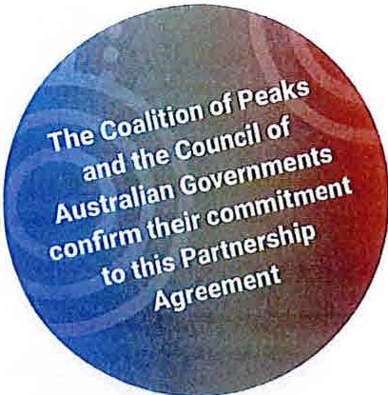

Signed for and on behalfof the Coalition of Peaks
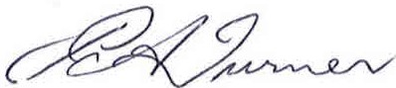
Patricia Turner AM ConvenerCoalition of Aboriginal and Torres Strait Islander
Peak Organisations

Signed for and on behalf of the Co nwealthof Australiaby
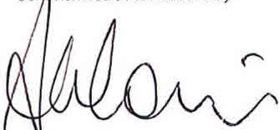
The Honourabl e Scott Morrison MP Prime Ministerof the Commonwealth of Australia

Signed for and on behalfof the Stateof Tasmania by

The Honourable WIii Hodgman MP Premier of the State of Tasmania

Signedfor andon behalf of the Stateof South Australiaby

The Honourable StevenMarshallMP
Premier of theState of South Australia

Signed for and on behalf of the Stateof Western Australia by

Th e Hon ourabl e M ark McGowan MLA Premier of the State of Western Australia

Signed for and on behalf of rhe State of Queensland by

The Honour abl e Annastacla Palaszczuk MP Premier of the State of Queensland

Signed for and on behalf of the Norihern Territory by
Signed for and on behalf of the Stateof New South Walesby

The Honourable Gladys Berejikllan MP Premier of the State of New South Wales

Signed for and on behalf of the Seate of Victoria by

The Honourable Danlel Andrews MP Premierof the State of Victoria

Signed fo r andon behalf of theAustralian Local Government Association by

Mayor David O'Loughlin
President of the Australian Local Government Association

Signed for and on behalf of the A11stra:ianCapital Terriiory by

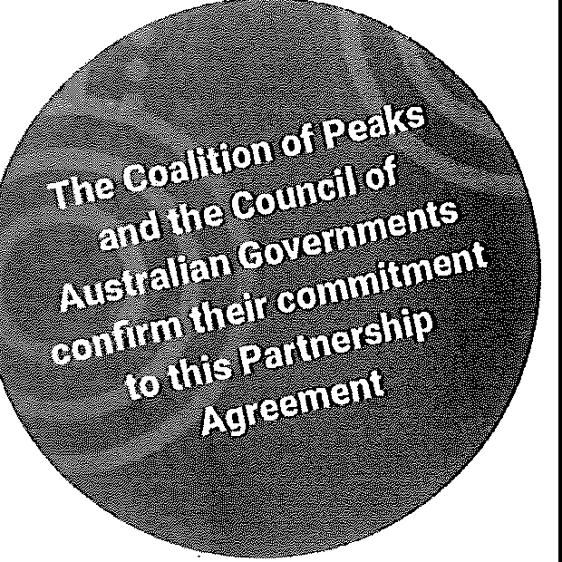

Signed for and on behalf of the Coalition of Peaks

Patricia Turner AM
Convener Coalition of Aboriginal and Torres Strait Islander Peak Organisations

Signed for and on behalf of the Co 1onwealth of Australia by
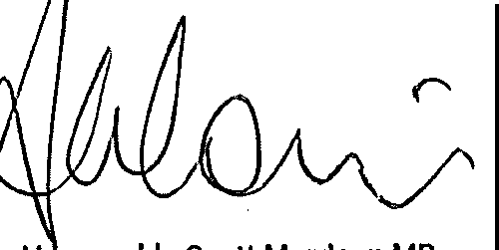
The H nourable Scott Morrison MP Prime Minister of the Commonwealth of Australia

Signed for and 011 behalf of the State of Tasmania by

The Honourable Will Hodgman MP Premier of the State of Tasmania

Signed for and on behalf of the State of South Australia by

The Honourable Steven Marshall MP Premier of the State of South Australia
Signed for and on behalf of the Stale of New South Wales by

The Honourable Gladys Berejlkllan MP Premier of the State of New South Wales

Signed for and on behalf of the Stale of Western Australia by

The Honourable Mark McGowan MLA Premier of the State of Western Australia
Signed for and on behalf of the State of Victoria by

The Honourable Daniel Andrews MP Premier of the State of Victoria

Signed for and on behalf of the state of Queensland by

The Honourable Annastacla Palaszczuk MP Premier of the State of Queensland
Signed for and on behalf of the Australian Local Government Association by

Mayor David O'Loughlln
President of the Australian Local Government Association

Signed for and on behalf of the Northern Territory by

Signed for and on behalfof the Australian Capital Territory by

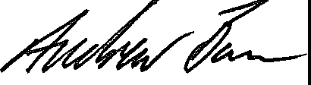

Signed for and on behalf of the Co 1onwealth of Australia by

The Honourable Scott Morrison MP
Prime Minister of the Commonwealth of Australia

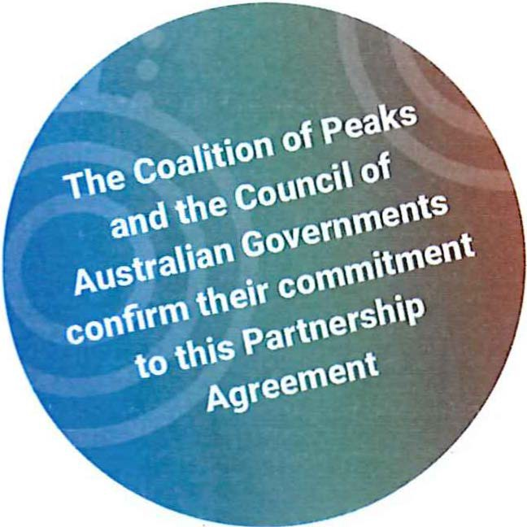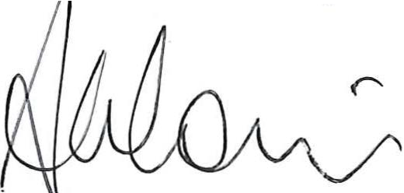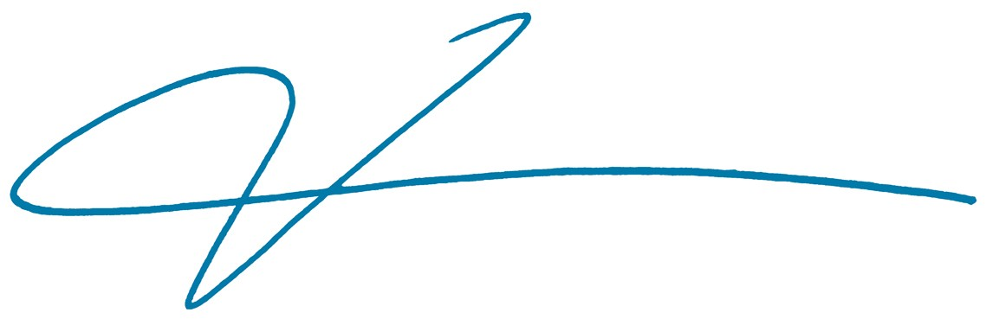Signed for and on behalf of the Coalition of Peaks

Patricia Turner AM
Convener Coalition of Aboriginal and Torres Strait Islander Peak Organisations

Signed for and on behalf of the State of South Australia by

The Honourable Steven Marshall MP
Premier of the State of South Australia

Signed for and on behalf of the State of Western Australia by

The Honourable Mark McGowan MLA
Premier of the State of Western Australia

Signed for and on behalf of the State of Queenslandby

The Honourable Annastacia Palaszczuk MP Premier of the State of Queensland

Signed for and on behalf of the Northern Territory by

The Honourable Michael Gunner MLA
Chief Minister of the Northern Territory of Australia
Signed for and on behalf of the State of Tasmania by

The Honourable Will Hodgman MP Premier of the State of Tasmania

Signed for and on behalf of the State of New South Wales by

The Honourable Gladys Berejiklian MP
Premier of the State of New South Wales

Signed for and on behalf of the State of Victoria by

The Honourable Daniel Andrews MP
Premier of the State of Victoria

Signed for and on behalf of the Australian Local Government Association by

Mayor David O'Loughlin
President of the Australian Local Government Association

Signed for and on behalf of the Australian Capital Territory by

Andrew Barr MLA
Chief Minister of the Australian Capital Territory

1ne
a
od the c
.,

oi pea\(,s
coa\\tiotl
onu c\', oi

Signed for andonbehalf of the

p.us\fa\iatl Go"ern ents \
coof,rf1\ tneir col\'\"''\ en
to \\'\is par\oers,\'\ p.greel\'\en\

Signed for andon behalf of rheCoalition of Peaks

Patricia Turner AM
Convener Coalition of Aboriginal and Torres Strait Islander Peak Organisations
C nwealthof Ausrraliaby
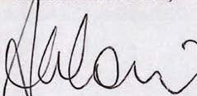
TheH nourable Scott Morrison MP
Prime Minister of the Commonwealth of Australia

Signed forandonbehalfof the Stateof Tasmania by

The Honourable WIiiHodgmanMP Premier of the State of Tasmania

Signed for andon behalf of the StateofSoul/1Australia by

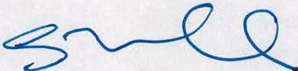
The Honourable StevenMarshallMP Premier of the State of South Australia
Signed for andonbehalf of the Stateof New South Wales by

The Honourable Gladys Bere]lkllan MP
Premier of the State of New South Wales

Signed forand on behalfof the Stateof Western AustraNa by

The Honourable Mark McGowan MLA Premier of the State of Western Australia
Signed forandon behalf of the Slateof Victoria by

The Honourable Daniel Andrews MP
Premier of the State of Victoria

Signed for andonbehalf of the S!ate ofQueensland by

The Honourable Annastacla Palaszczuk MP Premier of the State of Queensland
Signed for andonbehalf of theAustralian Local Government Association by

Mayor David O'Loughlln
President of the Australian Local Government Association

Signed forandonbehalfof the
Northern Territoty by

Signed for andonbehalf of the Australian capital Terriot ry by

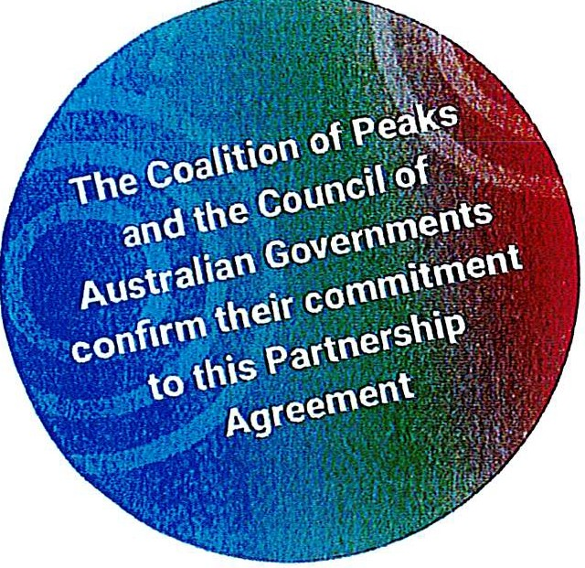
Signed for and on behalf of the Co onwealth of Australia by
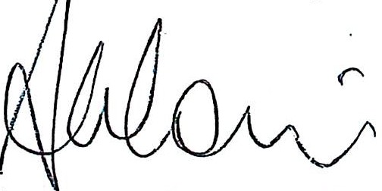
The Honourable Scott Morrison MP Prime Minister of the Commonwealth of Australia

Signed for and on behalf of the Coalition of Peaks

Patricia Turner AM
Convener Coalition of Aboriginlll and Torres Strait Islander Peak Organisations
Signed for and on behalf of the State of Tasmania by

The Honourable Will Hodgman MP Premier of the State of Tasmania

Signed for and on behalf of the State of South Australia by

The Honourable Steven Marshall MP Premier of the State of South Australia
Signed for and on behalf of the State of New South Wates by

The Honourable Gladys Berejikllan MP Premier of the State of New South Wales

Signed for and on behalf of the State of Western Australia by

The Honourable Mark McGowan MLA Premier of the State of Western Australia
Signed for and on behalf of the State of Victoria by

The Honourable Daniel Andrews MP Premier of the State of Victoria

Signed for and on behalf of the State of Queensland by

The Honourable Annastacla Palaszczuk MP Premier of the State of Queensland
Signed for and on behalf of the Australian Local Government Association by

Mayor David O'Loughlin
President of the Australian Local Government Association

Signed for and on behalf of the Northern Territory by

Signed for and on behalf of the Australian Capital Territory by

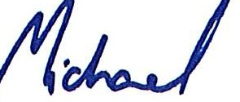

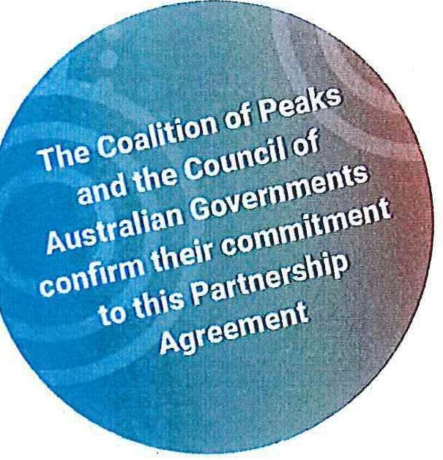

Signed for and on behalf of th e Coalition of Peaks

Patricia Turner AM
Convener Coalition of Aboriginal and Torres Strait Islander Peak Organisations

Signed for and on behalf of the Co '11onwealth of Australia by
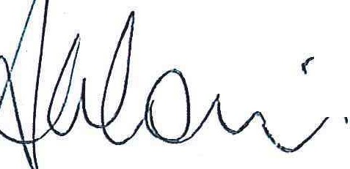
r
The Honourable Scott Morrison MP Prime Minister of the Commonwealth of Australia

Signed for and on bellalf of the State of Tasmania by

The Honourable WIii Hodgman MP Premier of the State of Tasmania

Signed for and on behalf of the Stale of South Australia by

The Honourable Steven Marshall MP Premier of the State of South Australia
Signed for and on behalf of the State of New South Wales by

The Honourable Gladys Berejlkllan MP Premier of the State of New South Wales

Signed for and on behalf of the State of Western Australia by

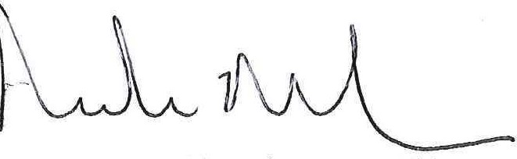
The Honourable Mark McGowan MLA Premier of the State of Western Australia
Signed for and on behalf of the State of Victoriaby

The Honourable Daniel Andrews MP
Premier of the State of Victoria

Signed for and on behalf of the State of Queensland by

The Honourable Annastacla Palaszczuk MP Premier of the State of Queensland
Signed for and on behalf of th e AustralianLocal Government Association by

Mayor David O'Loughlin
President of the Australian Local Government Association

Signed for and on be/Ja/f of the Northern Territory by

Signed for and on behalf of the Australian Capita l Territory by

Signf'd for and on b&ialf of theCo;;ilition of Peaks

Patricia Turner AM
Convener Coalition of Aboriginal and Torres Strait Islander Peak Organisations
Signed for and 011 behalf of //1e
Slate of Tasmania by

The Honourable WIii Hodgman MP
Premier of the State of Tasmania

Signed for and on behalf of the
Srate of South Australia by

The Honourable Steven Marshall MP
Premier of the State of South Australia
Signed for arrd on behalf of the
State of New South Wales by

The Honourable Gladys Berejlkllan MP Premier of the State of New South Wales

Sione d for and on behalf of the
Stare of\Vestern Australia by

The Honourable Mark McGowan Ml.A Premier of the Slate of Western Australia

.Signed for and on behalf of the State of Qveensfand by

The Honourable Annastacla Palaszczuk MP Premier of the State of Queensland
Signed tor and on behalf of the State of Victoria by
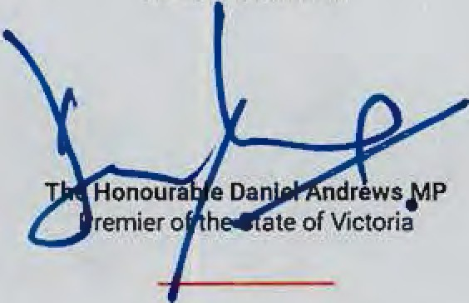

Signed for and on behalf of the Australian Local (',overnment Associati7,1 by

Mayor David O'Loughlln
President of the Australian Local Government Association

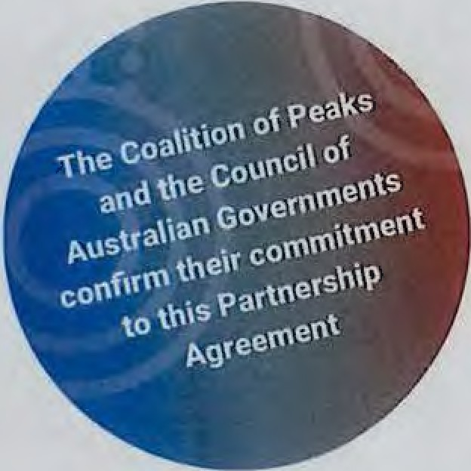
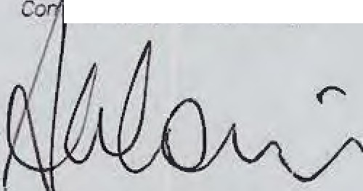
Signed for and on behalf of the Northern rerrr'tori, by

Signed for and on behalf of tbe Auslral:an C'api/a/ Territory by

Signed for and on behafl of rheGoa/Irion of Pcai·s

Patricia Turner AM
Convener Coalition of Aboriginal and TorresStrait Islander Peak Organisations
s:gnerl for and on behalf of the Stareof Tasmania by

The Honourable WIii Hodgman MP Premier of the State of Tasmania

Sgned for and on behalf of the Stilleof S011tlr A11sr1aliaby

Th e Hon ourable Steven Marshall MP
Premier of the State of South Australia
Signed for and on behalf of the Stateof Ueiv Sowh W;iles hy
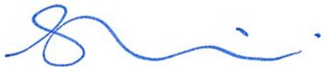
The Honourable Gladys Berejlkllan MP Premier of the State of New South Wales

S gnc-d for and on behalf of the St,1te of \Ves tern Austra1/.1 by

The Honour able Mark McGowan MLA Premier of the State of WesternAustralia
S,gncd for and on behalf of the Sea teof Victoria by

The Honourable Daniel Andrews MP Premier of the State of Victoria

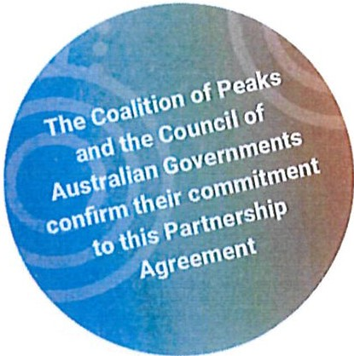
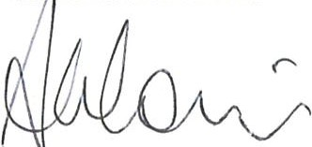
s,gned for and on behalf of the Slate of Queenslandby

The Honourable Annastacla Palaszczuk MP Premier of the State of Queensland

Signed for and on behalf of tile Northern Territory by
Signed for and on behalf of the At1srralian Loc;il Gover n ment 4ssocai rion by

Mayor David O'Loughlln
President of the Australian Local Government Association

Signed for and on behalfof the Austral,an Capital Territo1y by

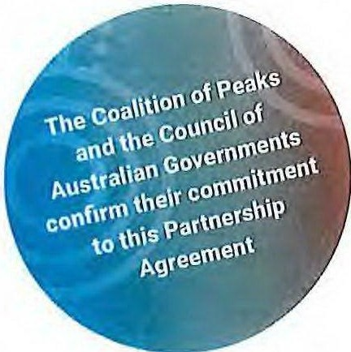

Signed for and on behafl o( the Coalition o( Peaks

Patricia Turner AM
Convener Coalition of Aboriginal and Torres Strait Islander Peak Organisations

Signed for and on behalf of the Con 71onwealth of Australia by
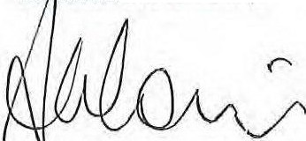
The Hon ourable Scott Morrison MP Prime Minister of the Commonwealth of Australia

Signed (or and on behalf of /he Stateof Tasmania by

The Honourable WIii Hodgman MP Premier of the State of Tasmania

Signed for and on behalf of the Slate of South Australia by

The Honourable Steven M arshall MP Premier of the State of South Australia
Signed (or and on behalf of the Stateof New South Wales by

The Honourable Gladys Berejlkllan MP Premier of the State of New South Wales

Signed for and on behalf of the State of Western Australia by

The Honourable Mark McGowan MLA Prem ier o f the State of Western Australia
Signed for and on behalfof tile
Stateor Victoria by

The Honourable Daniel Andrews MP Premier of the State of Victoria

Signed for and on behalf of the State or Queensland by

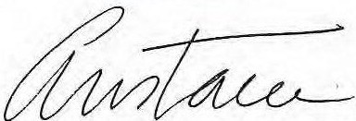
The Honourabl e Annastacla Palaszczuk MP Premier of the State of Queensland
Signed {or and on behalf of the Australian Local Government Association by

Mayor David O'Loughlln
President of the Australian Local Government Association

Signed for and on behalf of tile
Northern Territory by

The Honourable Michael Gunner MLA
Chief Minister of the Northern Territory of Australia
Signed for and on behalf of the A11stralia11 Capital Territory by

Andrew Barr MLA
Chief Minister of the Australian Capital Territory

. - -
---

- - --- - I -, /
- :.
'. ) , -

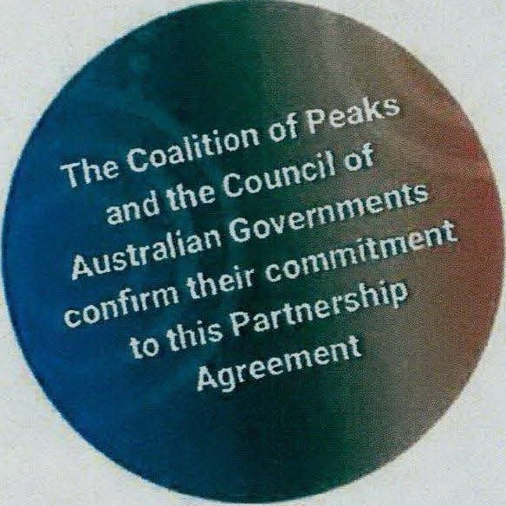

Signed for and on behalf of the Coalition of Peaks

Palrlcla Tum.- AM
Convener Coalition of Aboriginal and Torres Strait Islander
Peak brganisatiorn1

Signed for and on behalf of the Commonwealth of Australia by

The Honouiable Scott MontlOII MP
Prime Minister of the Commonwealth of Australia

Signed for and on behalf of the
State of Tasmania by

Premier of the State of Tasmania

Sir;,ned for and onbeha{f of the State of SouthAustralia by

The Honc>UJable Stwm M...,_I MP
Premierd 1he State of South Australia
Signed for and on behalf of the
State of New South Wales by

The Honourable Gladp Berejlldlan MP
Premier of theState of New South Wales

Signed for and on behalf of the
state of Western Austrafia b y

The Honoulllble Mn McOawan Ml.A
Premier of the State of Western Australia
Signed for and on behalf of the
Stzte of Victoria by

The Honounlble Dante! Andmn MP
Pr:emier of the State of Victoria

Signed for and on behalf of the
Stateof Queensland t,y

The Honounible Annutacla Pelnzczuk MP
Premier of the Stete of Queensland
Signed forand on behalf of the Allstrallan LDcal
Government Association by

Mayor David O'Loughlln
President of the Austranan Local G<wemment Association

Signed for and on behalf of the
. Northern Territory by
I

The Honourable Mlchael Gunner MLA
Chief Minister of theNorthern Territory of Australia

Signed for and on behalf of the
AustraHan Capital Territory by

Andrew BIIT MLA
Chief Minister of the Australian Capital Territory

Schedule A

COALITION OF ABORIGINAL AND TORRES STRAIT ISLANDER PEAKS MEMBERSHIP AT TIME OF SIGNING

National Members
Congress of Aboriginal and Torres Strait Islander Nurses and Midwives
First Nations Media Australia
First Peoples Disability Network
Indigenous Allied Health Australia
Lowitja Institute
National Congress of Australia’s First Peoples
National Aboriginal and Torres Strait Islander Health Worker Association
National Aboriginal and Torres Strait Islander Legal Services
National Aboriginal Community Controlled Health Organisation
National Family Violence Prevention Legal Services Forum
National Native Title Council
SNAICC – National Voice for Our Children
The Healing Foundation
Australian Indigenous Doctors’ Association

State and Territory Members
New South Wales Coalition of Aboriginal Peaks (CAPO):
- NSW Aboriginal Land Council
- NSW/ACT Aboriginal Legal Services
- Link Up NSW
- NSW Aboriginal Education Consultative Group*
- NSW Aboriginal Health and Medical Research Council
- NSW Aboriginal Child, Family and Community Care State Secretariat
- First Peoples Disability Network
Victorian Aboriginal Executive Council:
- Victorian Aborigines Advancement League
- Koori Youth Council
- Victorian Aboriginal Education Association Incorporated
- Victorian Aboriginal Legal Service
- Victorian Aboriginal Child Care Agency
- Djirra
- Federation of Victorian Traditional Owner Corporations (FVTOC)
- Victorian Aboriginal Housing Board
- Victorian Aboriginal Health Service
- Victorian Aboriginal Community Controlled Health Organisation
- Victorian Aboriginal Community Services Association Ltd
Queensland Coalition of Peaks being established including:
- Aboriginal & Torres Strait Islander Legal Service (Qld) Ltd
- Queensland Aboriginal and Torres Strait Islander Child Protection Peak Limited
Western Australia:
- Aboriginal Health Council of Western Australia
South Australia:
- Aboriginal Legal Rights Movement Incorporated, consulting with a policy group of Aboriginal Community Controlled Organisations in South Australia
Tasmania:
- Tasmanian Aboriginal Centre
Australian Capital Territory:
- ACT Aboriginal and Torres Strait Islander Elected Body
Northern Territory Aboriginal Peak Organisations:
- Aboriginal Medical Services Alliance NT
- Central Land Council
- Northern Land Council

* Also provides a national perspective pending the formation of a national peak for Indigenous education.

