PFAS Contamination Response Protocol
NATIONAL FRAMEWORK FOR RESPONDING TO PFAS CONTAMINATION
The PFAS Contamination Response Protocol (the Protocol) outlines agreed key priorities and guidance for governments in Australia when responding to PFAS contamination. It covers PFAS contamination on government-owned sites and other sites where government activities have resulted in PFAS contamination. The guidance is applicable to both loss of containment events (e.g. spills) and legacy contamination.
The widespread use of PFAS and unpredictable mobility of these chemicals in the environment means that clearly determining all sources can be very challenging. Additionally, PFAS contamination may cross jurisdictional boundaries and there are often multiple responsible entities. Working together to quickly determine roles and necessary actions is the best way to overcome these challenges and protect the environment and, as a precaution, protect human health.
The Protocol is a quick-reference tool to help governments work together to respond rapidly and effectively to PFAS contamination. It outlines high-level information about government roles and processes and directs the user to more detailed, specifically relevant guidance materials. It aims to assist government agencies to collaborate more effectively, respond more consistently, and provide clear information to communities and industry on what they can expect from governments in Australia on PFAS contamination.

Scope
The Protocol will | The Protocol will not
- Outline governments’ priorities for responding to PFAS contamination.  - Identify and build on existing guidance material that can assist when responding to PFAS contamination.  - Provide guidance on how governments can work together to determine roles and respond to contamination consistently, particularly where multiple entities and/or jurisdictions are involved.  - Give examples of how governments in Australia may work together to manage risks arising from PFAS contamination. | - Override any existing legislation, agreements or other guidance, or exempt governments from any usual obligations.  - Provide a set of sequential steps to respond to specific instances of PFAS contamination.  - Extensively cover guidance for environmental regulators. More detail can be found in the PFAS National Environmental Management Plan (Appendix B to the National Framework for Responding to PFAS Contamination).  - Create new obligations for non-government entities.

The Protocol
The Protocol outlines general guidance relating to three priorities for responding to PFAS contamination. These priorities are of equal importance and may occur simultaneously. For each priority, the protocol provides information on the steps that should be undertaken, gives guidance on determining roles, and describes how governments can work together.

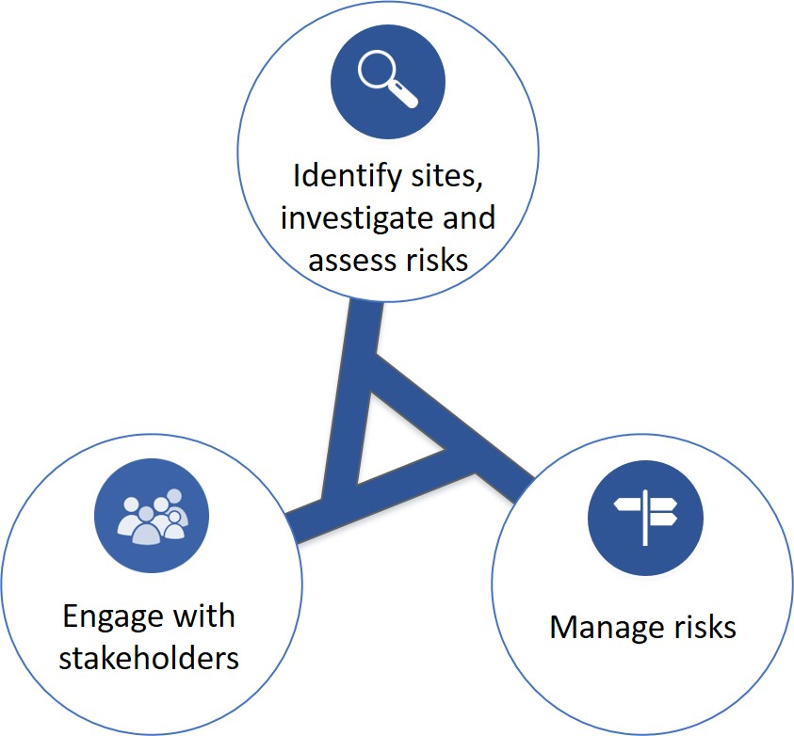
Figure A: Priorities for responding to PFAS contamination

The protocol also identifies other documents that governments may refer to when acting on these priorities. The documents are listed at Attachment A.

Key terms
There are some key terms used in this document.
Entities are agencies, organisations, businesses and similar bodies, and can be government or non-government.
Government agencies are offices of the Australian Government, state and territory governments, and local governments, including statutory authorities and other bodies created by legislation.
Government-owned sites are parcels of land owned by either the Australian Government, a state or territory government, or a local government.
PFAS-related activities are the current or historic use and disposal of consumer and industrial products or the application of industrial processes that involve products containing PFAS. It is important to note that, while public awareness is mostly about PFAS use in aqueous film-forming foams for firefighting, PFAS are also used extensively in a wide range of industrial processes and consumer and industrial products, including but not limited to, chromium plating, medical imaging, various fabric treatments, cooking appliances, paper treatments, and in aviation hydraulic fluid.

Key entities
The key entities discussed in this document are:
Known or potential polluters | Entities that have or may have contributed to PFAS contamination at a given site through PFAS-related activities.
Government land lessees | Entities that lease government land and have obligations under a lease agreement. They may or may not be a known or potential polluter.
Governments | The Australian Government, state and territory governments, and local governments.
Environmental regulators | Government agencies that have regulatory functions in relation to environmental contamination.  - On state and territory land (including local government sites), environment regulators are environment departments and EPAs.  - On Commonwealth land, the environmental regulatory function depends on which agency is responsible for the land.
Lead entity(ies) | Known or potential polluters that have been identified by the environmental regulator(s). These entities have certain responsibilities for responding to PFAS contamination, as outlined in the Protocol. Lead entity(ies) may be government or non-government entities. A known or potential polluter may agree to undertake some or all of the responsibilities of another known or potential polluter to streamline activities.  Note: in rare circumstances where a polluter cannot be identified, the lead entity could be an entity as prescribed under existing relevant legislation.
Health, food, primary industry and agriculture agencies | Government agencies that provide expert advice on human health, food, agriculture and trade matters. These departments may also have regulatory functions in these areas.
First Minister(s’) departments | Government agencies that coordinate whole-of-government activities on behalf of individual jurisdictions.
Expert advisers | Entities or people holding, or having ready access to, expert knowledge on management and disposal of PFAS and management of a PFAS contamination incident. Areas of expertise could include community engagement, medical, health, environmental effects, monitoring, remediation and environmental auditing.

This is not an exhaustive list of all entities that may be involved in responding to PFAS contamination. Other entities may be involved on a case-by-case basis.

Priorities

Priority: Identify sites, investigate and assess risks
Governments should take measures to identify sites potentially contaminated through current or historic use, testing, storage or disposal of products containing PFAS. Potentially contaminated sites should be prioritised and investigated in accordance with the National Environment Protection (Assessment of Site Contamination) Measure 1999 (ASC NEPM), state and territory regulatory systems for contaminated sites, and PFAS National Environmental Management Plan (PFAS NEMP) (Appendix B to the National Framework for Responding to PFAS Contamination). The ASC NEPM investigation process is iterative and includes:
- A preliminary assessment, which involves inspecting and identifying the characteristics of the site, including potential off-site sources and receptors.
- Where appropriate, a detailed assessment, which usually includes assessment of potential risks to human health and the environment.

What are the roles of the key entities?
Known or potential polluters (including all governments) | In accordance with the ASC NEPM and the PFAS NEMP, identify sites owned or leased by the entity where PFAS-related activities have been undertaken, and other sites where the entity may have conducted PFAS-related activities.  Notify relevant agencies (including the environmental regulator(s)) where an entity has undertaken a PFAS-related activity in another jurisdiction and/or PFAS contamination may have spread into another jurisdiction.
Environmental regulator(s) of the relevant jurisdiction(s) | Determine lead entity(ies) (see section below).  Work with / monitor the lead entity’s(ies’) investigations and conduct regulatory activities to ensure compliance with relevant legislation and/or guidelines, as appropriate.
Lead entity(ies) | In accordance with the ASC NEPM and PFAS NEMP, conduct investigations and assess risks, with the assistance and oversight and advice of government and the advice of non-government expert advisers, in consultation with all relevant environmental regulator(s) and entities (e.g. government land lessees).
Health, food, primary industry and agriculture agencies of the relevant jurisdiction(s) | Advise the lead entity(s) on matters including health advice, human health risk assessments, hydrology, food, trade and market access, as appropriate, in consultation with relevant environmental regulator(s).
First Minister(s’) department(s) | Monitor and, where necessary, coordinate relevant agencies in managing PFAS contamination.  Work with other jurisdictions to facilitate consistency.

How will governments identify actions and roles?
This Protocol outlines a standard process for determining the lead entity(ies), with the aim to foster effective collaboration amongst regulators, known and potential polluters and other stakeholders (e.g. government land lessees). It is designed to provide transparency to governments, industry and communities alike about the process for determining actions and roles. These decisions should be made by timely negotiations undertaken in good faith, with the wellbeing of affected communities and protection of the environment as priorities.
The below figure and box outline the standard process for relevant environment regulators, known and potential polluters and other stakeholders to work together to determine actions and roles.

Figure B: Flow chart for determining activities and roles at multi-jurisdiction / multi-entity sites
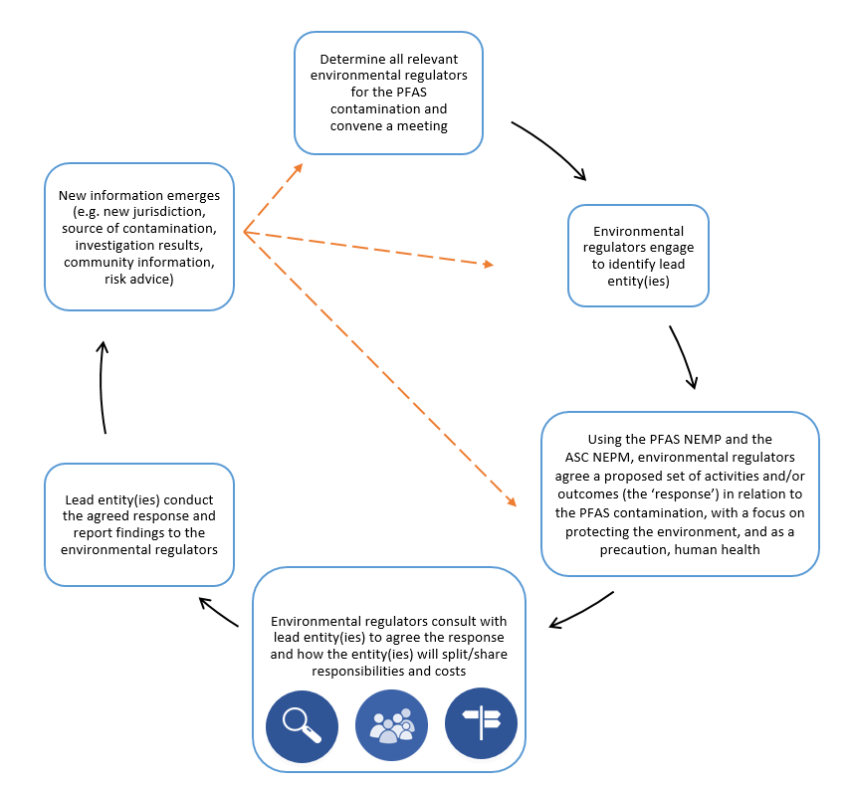

Determining the lead entity(ies)
The relevant environmental regulator(s) will work together to agree on the lead entity(ies) where contamination is identified.
Unless otherwise stipulated in legislation, the environmental regulator(s) will identify known or potential polluters, or require another party to do so. Environmental regulator(s), or the required party, should undertake a thorough analysis to ensure all potential polluters are identified.
If only one entity is known to or may be the polluter, it will be deemed to be the lead entity. Where there are multiple known or potential polluters, the polluters will have joint responsibility to lead. A polluter may agree to undertake some or all of the responsibilities of another polluter to streamline activities, in consultations with the environmental regulator(s).
Based on new information and consultation with known and potential polluters, the environmental regulator(s) may determine that an entity is no longer a lead entity, or that a new entity is a lead entity, at any time.
How is responding to a loss of containment event different to legacy contamination?
The information provided in the Protocol is applicable to both loss of containment events and legacy contamination. However, where a large amount of PFAS contamination enters the environment suddenly, such as during a loss of containment event, polluters need to take actions quickly. The following contact list will assist these parties to respond rapidly and involve the appropriate regulatory bodies, and commence the outlined actions, as soon as possible.
For Commonwealth land, polluters should contact the government agency that manages the property.
Australian Capital Territory  Pollution Hotline  13 22 81 | South Australia  Pollution and Environment Incident Reporting Hotline  (08) 8204 2004 (metro callers)  1800 623 445 (non-metro callers)
New South Wales  Environment Line  131 555 | Tasmania  Pollution Incidents and Complaints Hotline  1800 005 171
Northern Territory  Pollution Hotline  1800 064 567 | Victoria  Pollution Hotline  1300 372 842
Queensland  Pollution Hotline  1300 130 372 | Western Australia  Pollution Watch Hotline  1300 784 782
Commonwealth: Where Australian Government entities are involved, the relevant agency/ies (e.g. Defence, Infrastructure, Airservices, Environment) should be contacted through the usual channels.

Priority: Engage with stakeholders
Engaging with local communities and stakeholders is a critical part of responding to PFAS contamination. Timely, open, transparent and consistent communication is essential to share information, address concerns, explain actions, and advise on risk management actions. This should be undertaken in accordance with the PFAS Information Sharing, Communication and Engagement Guidelines (Appendix C to the National Framework for Responding to PFAS Contamination). This is an ongoing activity at all stages of responding to PFAS contamination.

What are the roles of the key entities?
Lead entity(ies) | Lead prompt, open and transparent stakeholder engagement about responding to PFAS contamination.  Share information and data about investigations, risk management and planned engagement activities with relevant environmental regulator(s), health, food, primary industry and agriculture agencies, other key agencies and relevant entities.  Seek and consider advice from relevant environmental regulator(s), health, primary industry and agriculture departments, other relevant entities (e.g. government land lessees) and expert advisers on engagement activities.  Engage with communities potentially affected by PFAS contamination and key influencers.
Environmental regulator(s) of the relevant jurisdiction(s) | Advise the lead entity(ies) and stakeholders affected by PFAS contamination about regulatory activities and possible environmental impacts as appropriate.
Health, food, primary industry and agriculture agencies of the relevant jurisdiction(s) | Support the lead entity(ies) and stakeholders affected by PFAS contamination by providing advice on matters including health, human health risk assessments, hydrology, food, trade and market access, as appropriate, in consultation with relevant environmental regulator(s).
First Minister(s’) department(s) | Monitor and, where necessary, facilitate participation in engagement activities.  Work with other jurisdictions to facilitate consistency.

Priority: Manage risks
As soon as an understanding of the risks begins to emerge, governments should ensure that they are managed in a consistent way. Any response to risks resulting from PFAS contamination, including remedial actions, should be based on evidence and commensurate with the level of risk.

What are the roles of the key entities?
Lead entity(ies) | Consider advice provided by relevant environmental regulator(s), health, primary industry and agriculture departments, other key agencies and expert advisers on risk management actions.  Conduct activities as appropriate to manage the risks identified in the investigation process, in consultation with relevant environmental regulator(s).
Environmental regulator(s) of the relevant jurisdiction(s) | Monitor activities of the lead entity(ies) and conduct relevant regulatory activities as appropriate.  Where necessary, coordinate regulatory and compliance actions.
Health, food, primary industry and agriculture agencies of the relevant jurisdiction(s) | Advise the lead entity(ies) and stakeholders affected by PFAS contamination on risk mitigation as appropriate, in consultation with relevant environmental regulator(s).  Where necessary, coordinate regulatory and compliance actions.
First Minister(s’) department(s) | Monitor and, where necessary, coordinate relevant agencies in managing PFAS contamination.  Work with other jurisdictions to facilitate consistency.

What are some examples of risk management responses?
Risk management responses will vary depending on a range of factors including:
- Technical considerations (e.g. the level of contamination, hydrogeology, exposure pathways, available technology)
- Community needs
- Financial and logistical feasibility
- Provision of critical public services.
Any response should be tailored for individual circumstances, based on evidence, and commensurate with the level of risk. Agencies can consult the documents identified in Attachment A for further information on appropriate responses.
Responses can be categorised as source management, pathway management or receptor management. Generally, source management is preferable to pathway management, and pathway management is preferable to receptor management. Some examples of risk management responses that may be appropriate to manage the risk posed by PFAS contamination include:

Source management
Measures that may remove the source of contamination.
- Substituting products containing PFAS (particularly PFOS, PFOA or PFHxS) with alternative products, ensuring alternative products meet the requirements of relevant international conventions and relevant guidance.
- Replacing contaminated infrastructure.
- Containing and preventing run-off from sites where PFAS-containing products are, or have been, used.
- Disposing of PFAS stocks, or waste/infrastructure contaminated by PFAS with consideration of:
  - availability of disposal sites and technologies
  - guidance from the relevant state/territory regulator responsible for environmental protection, including in relation to transport and disposal
  - the Stockholm Convention on Persistent Organic Pollutants
  - the Basel Convention on the Control of Transboundary Movements of Hazardous Wastes and Their Disposal.

Pathway management
Measures that may prevent the contamination reaching an exposure pathway.
- Immobilising the contaminant to prevent migration or leaching.
- Storing contaminated soil or other material in a contained facility.
- Filtering/treating water.
- Capping groundwater bores.

Receptor management
Measures focussed on the receptor of the contamination (people such as those in surrounding communities, and the environment), where harm may occur.
- Providing information to people about exposure pathways and risks of exposure to PFAS.
- Providing food advisories to people likely to consume commodities produced on PFAS contaminated land or water.
- Providing alternative drinking water for a specified period of time to people whose drinking water source consistently exceeds the tolerable daily intake for PFAS, where the tolerable daily intake has been determined.
- Restricting animal access to contaminated land or water.

ATTACHMENT A: Guidance DOCUMENTS
Guidance | Identify sites, investigate & assess risks | Engage with stakeholders | Manage risks
Appendices to the National Framework for Responding to PFAS Contamination
The PFAS National Environmental Management Plan – Appendix B
PFAS Information Sharing, Communication and Engagement Guidelines – Appendix C
Health Based Guidance Values for PFAS for use in site investigations in Australia – Appendix D
Environmental Health Standing Committee (enHealth) Guidance Statements on PFAS – Appendix E
Australian Health Protection Principal Committee PFAS Factsheet – Appendix F
Food Regulation Standing Committee Statement PFAS and the general food supply – Appendix G
Additional guidance on environmental health
The Environmental Health Risk Assessment guidelines for assessing human health risks from environmental hazards and associated Australian Exposure Factor Guide 2012, developed by the Environmental Health Standing Committee (enHealth)
Additional guidance on environmental protection
The Environment Protection and Biodiversity Conservation Act 1999
Additional guidance on food
The Food Regulation Agreement (2008), and Australia’s regulatory systems for food
Additional guidance on chemicals management
The Industrial Chemicals (Notification and Assessment) Act 1989 and its proposed replacement, the Industrial Chemicals Bill 2017, and state and territory regulatory systems for chemicals
The National Industrial Chemicals Notification and Assessment Scheme (NICNAS) Information Sheet on PFAS
The NICNAS Alerts on PFAS
Additional guidance on contaminated sites
National Environment Protection (Assessment of Site Contamination) Measure 1999 (ASC NEPM), and state and territory regulatory systems for contaminated sites and environmental protection
Additional guidance on waste management
The National Waste Policy, and state and territory regulatory systems for waste management, and in particular, hazardous waste
Additional guidance on water standards
The National Water Quality Management Strategy, including
- The Australian Drinking Water Guidelines
- The Australian and New Zealand Guidelines for Fresh and Marine Water Quality
- The Australian Guidelines for Water Quality Monitoring and Reporting
- The Australian Guidelines for Water Recycling
- The Guidelines for Managing Risks in Recreational Water
- The Guidelines for Groundwater Quality Protection in Australia.
Additional guidance on community engagement
Responding to Environmental Health Incidents - Community Engagement Handbook, developed by enHealth

For example, the Department of Infrastructure and Regional Development is responsible for the regulation of environmental protection at most federally leased (owned) airports (Adelaide, Alice Springs, Archerfield, Canberra, Bankstown, Brisbane, Camden, Darwin, Essendon, Gold Coast, Hobart, Jandakot, Launceston, Melbourne Tullamarine, Moorabbin, Parafield, Perth, Sydney Kingsford Smith and Townsville), and the Department of Defence is responsible for environmental management on Defence land. The Department of the Environment and Energy is also responsible for the protection of matters of national environmental significance as defined in the Environment Protection and Biodiversity Conservation Act 1999 (Cth).
See Key Entities section for further information on environmental regulators
See Key Entities section for further information on environmental regulators.
See Key Entities section for further information on environmental regulators.
See Key Entities section for further information on environmental regulators

