Intergovernmental Agreement on Fuel Excise Relief 2026
An agreement between:
- the Commonwealth of Australia and
- the States and Territories, being:
  - New South Wales (NSW)
  - Victoria (VIC)
  - Queensland (QLD)
  - Western Australia (WA)
  - South Australia (SA)
  - Tasmania (TAS)
  - the Australian Capital Territory (ACT) and
  - the Northern Territory (NT)

Part 1 – Objective of this Agreement
- Through this Agreement, the Commonwealth of Australia (the Commonwealth) and the States and Territories (the States) commit to contributing to a nationally coordinated Fuel Excise Relief Program (the Program) to reduce cost-of-living pressures and support economic activity.

- The Program will reduce fuel excise and excise-equivalent customs (fuel duty) rates by an additional 10.9%, over and above the announced 50% reduction to the fuel duty rates for three months from 1 April 2026 to 30 June 2026, for the same fuel products as the temporary halving of fuel duty rates.

- The States will compensate the Commonwealth for the lost fuel duty revenue relating to the additional 10.9% reduction, estimated to total $400 million.

- This Agreement outlines the roles and responsibilities of the Commonwealth and the States in relation to governance and funding arrangements.

Part 2 – Parties and Operation of the Agreement
- The Parties to this Agreement (the Parties) are the Commonwealth of Australia and the States.

- This Agreement will commence when the Commonwealth and at least one other Party sign it.

- This Agreement will expire on 31 December 2026.

- This Agreement may be varied or extended as set out in Part 4 – Governance Arrangements.

Part 3 – Roles and Responsibilities

Role of the Commonwealth
- The Commonwealth agrees to:

- deliver a temporary 10.9% reduction to fuel duty rates over and above the announced 50% reduction to the fuel duty rates, from 1 April 2026 to 30 June 2026. This will bring the fuel duty rates for petrol and diesel down by an additional 5.7 cents per litre (c/L), with the total fuel duty rate being reduced from 52.6 c/L to 20.6 c/L, for the relevant three-month period. The reduction would apply to the same fuel products as the temporary halving of fuel duty rates.

- invoice the States for their share of Fuel Excise Relief in accordance with the terms and conditions of this Agreement.

Role of the States
- The States agree to provide a financial contribution to the Commonwealth to partially compensate the Commonwealth for the lost fuel duty revenue, equal to the State funding contributions in Part 5 – Funding Arrangements.

Part 4 – Governance

Enforceability of the Agreement
- The Parties do not intend any of the provisions of this Agreement to be legally enforceable. However, this does not lessen the Parties’ commitment to this Agreement.

Variation, extension and/or termination of the Agreement
- This Agreement may be varied, extended or terminated at any time by agreement in writing by all Parties.

- The Commonwealth will consult with States if the Commonwealth intends to extend the Program. The Commonwealth will consult at a reasonable period prior to the expiration of this Agreement, and prior to any public announcement.

- A State may vary or terminate its participation in this Agreement at any time by agreement in writing between that State and the Commonwealth.

- A State varying or terminating its participation in this Agreement does not impact any other State’s commitment to this Agreement.

Part 5 – Funding Arrangements
- The States agree to provide up to a maximum total of $400,000,000.00 to the Commonwealth in accordance with this Agreement.

- Individual State funding contributions are outlined in Table 1 and are fixed for the duration of this Agreement.

Table 1: Financial Contributions
State | 2026-27
NSW | $106,910,909.89
VIC | $109,256,426.45
QLD | $69,423,440.17
WA | $33,101,472.71
SA | $38,138,602.20
TAS | $15,254,126.98
ACT | $8,223,952.80
NT | $19,691,068.80
Total | $400,000,000.00

- For the avoidance of doubt, if one State varies, terminates or does not sign this Agreement, the financial contributions as shown for any other State in Table 1 will not be adjusted.

- If there is a significant disruption to fuel supply between 1 April and 30 June, that has a significant impact on sales volumes of liquid fuels covered by this agreement, the Commonwealth and States agree to examine the $400 million original estimate of the 5.7 cent fuel excise reduction to consider if a change is required and agree any revisions based on realised volumes.

Calculation of the distribution of State financial contributions
- The distribution of funding to be paid by the States has been determined based on the GST revenue sharing relativities for 2025-26, as recommended by the Commonwealth Grants Commission.

- The calculations are published in Table C.10 on page 307 of the 2025-26 Mid-Year Economic and Fiscal Outlook. Table 2 replicates the information below, and applies the adjusted population shares to the $400,000,000.00:
Table 2: Calculation of funding share
State | Estimated 31 December 2025 population  (1) | GST relativities for 2025-26  (2) | Adjusted Population  (1) x (2) | Share of Adjusted Population | State Financial Contribution
NSW | 8,643,661 | 0.86034 | 7,436,487 | 26.7% | $106,910,909.89
VIC | 7,120,965 | 1.06722 | 7,599,636 | 27.3% | $109,256,426.45
QLD | 5,709,926 | 0.84571 | 4,828,942 | 17.4% | $69,423,440.17
WA | 3,069,954 | 0.75000 | 2,302,466 | 8.3% | $33,101,472.71
SA | 1,910,220 | 1.38876 | 2,652,837 | 9.5% | $38,138,602.20
TAS | 576,488 | 1.84053 | 1,061,043 | 3.8% | $15,254,126.98
ACT | 487,993 | 1.17223 | 572,040 | 2.1% | $8,223,952.80
NT | 265,897 | 5.15112 | 1,369,667 | 4.9% | $19,691,068.80
Total | 27,785,104 | na | 27,823,119 | 100.0% | $400,000,000.00

Payment mechanism
- The Commonwealth Treasury will send invoices to State Treasuries within 10 working days from 1 July 2026 or, if Clause 19 is triggered, a date determined by agreement between the Commonwealth and the relevant State.

- Payments from the States will be made within 20 working days of the date of the invoice.

The Parties have confirmed their commitment to this agreement as follows:
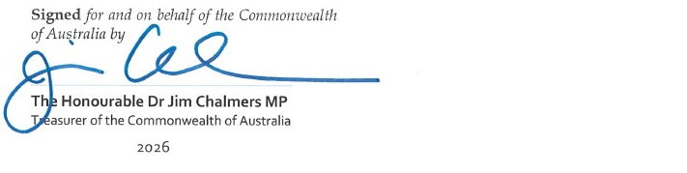
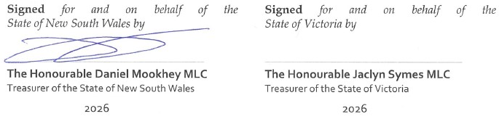
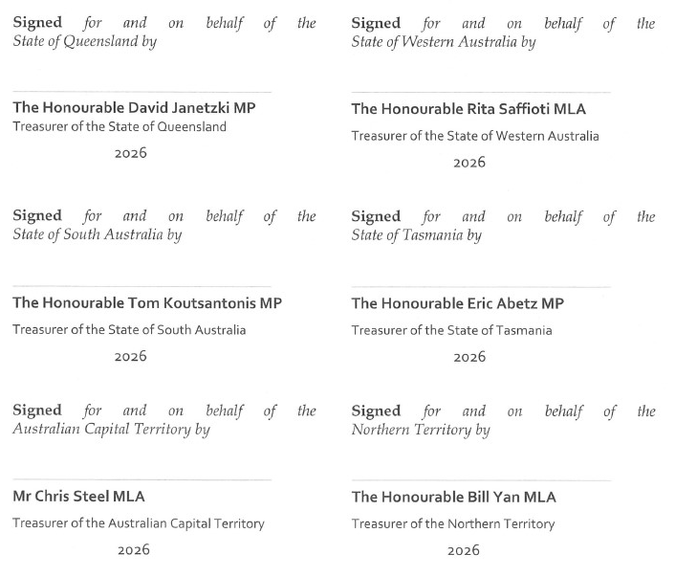
The Parties have confirmed their commitment to this agreement as follows:
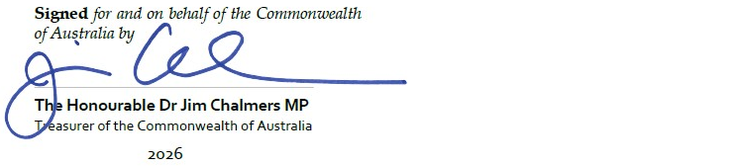
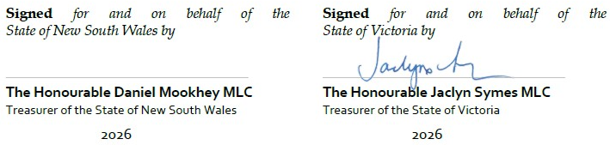
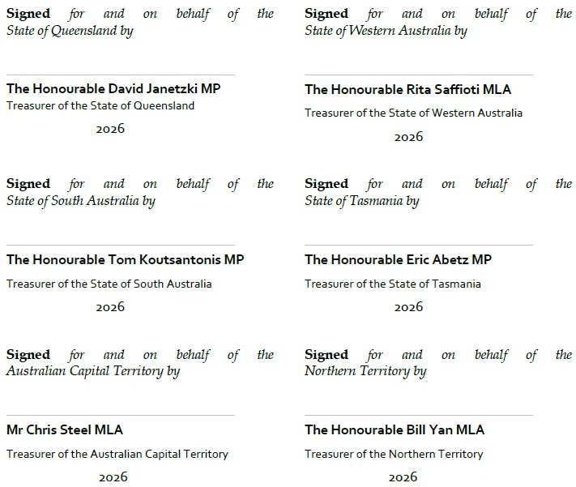
The Parties have confirmed their commitment to this agreement as follows:
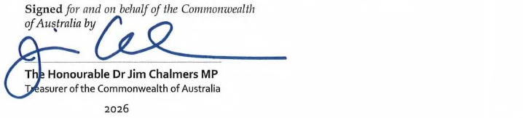
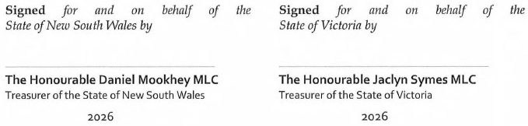
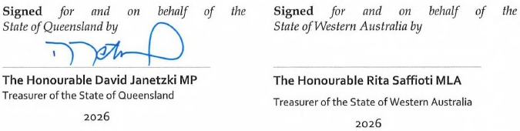
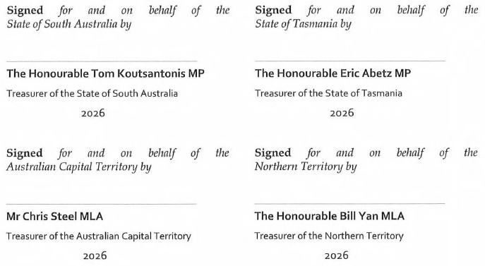

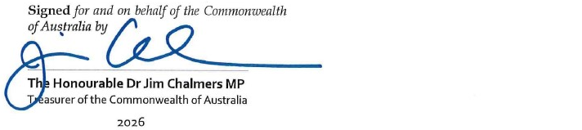
The Parties have confirmed their commitment to this agreement as follows:
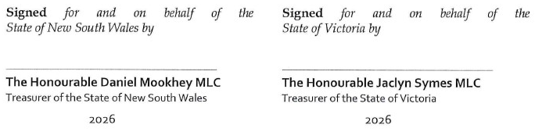
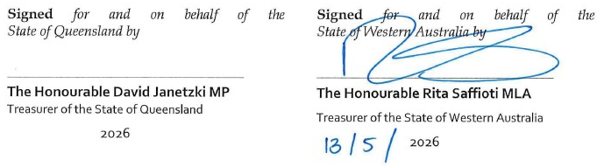
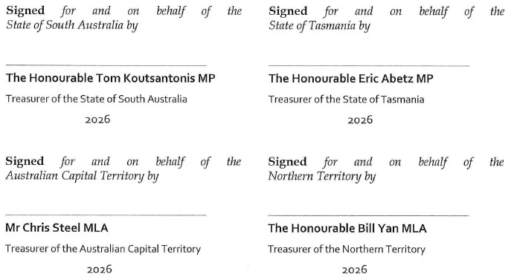

The Parties have confirmed their commitment to this agreement as follows:
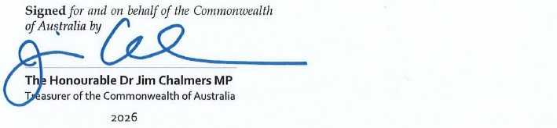
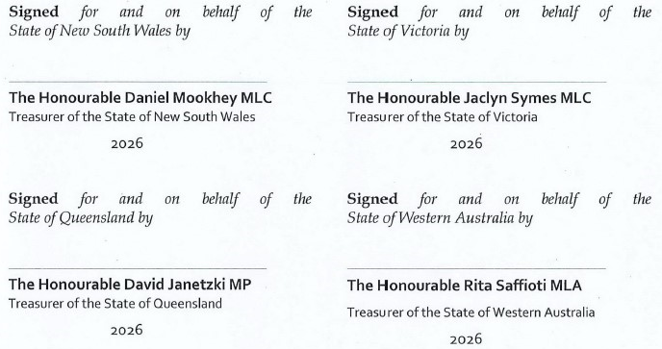
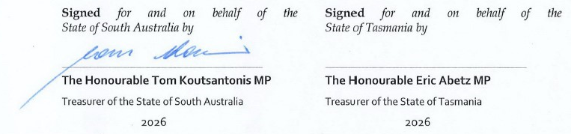
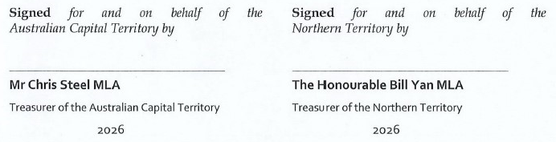

The Parties have confirmed their commitment to this agreement as follows:
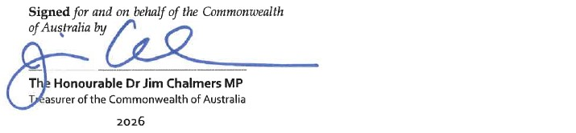
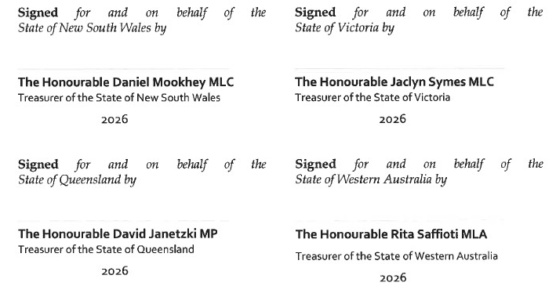
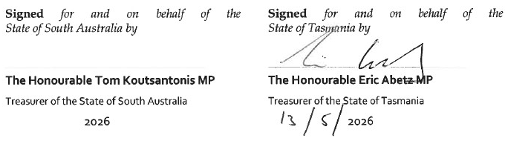
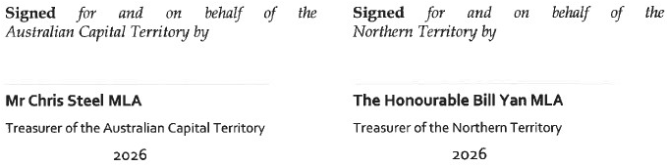

The Parties have confirmed their commitment to this agreement as follows:
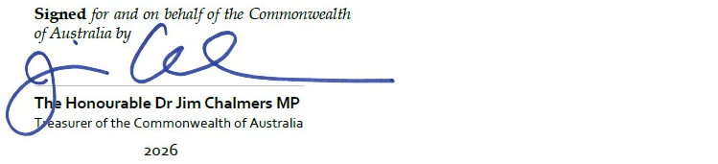
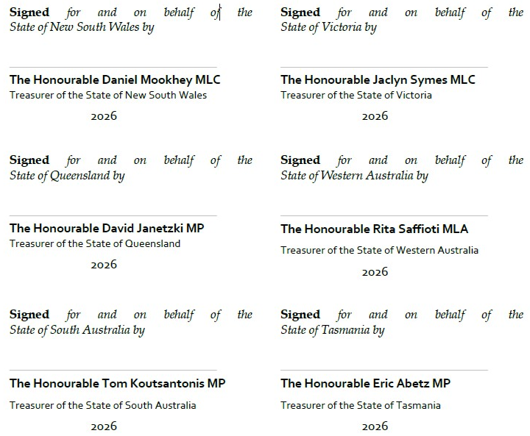
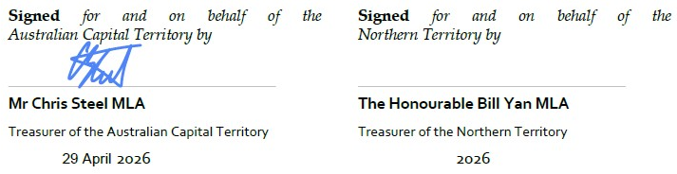

The Parties have confirmed their commitment to this agreement as follows:
