**Brisbane 2032 Olympic and Paralympic Games**

Intergovernmental Agreement

Schedule A: Brisbane 2032 Olympic and Paralympic Games venue infrastructure

Version 2.0, 2025

This Schedule outlines the governance and delivery of venue infrastructure for the Brisbane 2032 Olympic and Paralympic Games.

An agreement between:

* The **Commonwealth of Australia**; and
* The **State of Queensland**

PART 1 – FORMALITIES   
Parties to this Schedule

1. This Schedule is between the Commonwealth of Australia (Commonwealth) and the State of Queensland (Queensland).

Terms of the Schedule

1. This Schedule will commence as soon as both the Commonwealth and Queensland have signed both the Brisbane 2032 Olympic and Paralympic Games Intergovernmental Agreement (IGA) and this Schedule.
2. This Schedule covers the period up until and inclusive of the Games of the XXXV Olympiad 2032 and the 2032 Paralympic Games (collectively, the Brisbane 2032 Games) and will cease upon expiry of the IGA unless the parties agree in writing to an earlier date.
3. Any provisions of this Schedule dealing with post the Brisbane 2032 Games use and/or disposal of any venue will continue to operate in accordance with their terms notwithstanding the expiry or termination of this Schedule pursuant to clause 3.

Schedule to be read together with IGA

1. This Schedule is to be read together with the IGA, the Federation Funding Agreements Framework, and (unless the context requires otherwise) clauses 5 to 13 and 40 to 42 of the IGA apply for the purpose of interpreting this Schedule.

Enforceability of the Schedule

1. The parties do not intend any of the provisions of this Schedule to be legally enforceable. However, that does not lessen the commitment of the parties to this Schedule.

# PART 2 – PROJECT OUTPUTS

Outputs

1. The outputs of this Schedule will be the planning and delivery of sporting and community venues set out in Annexure A (together, the venues). This Schedule provides the overarching framework to manage the partnership between the Commonwealth and Queensland on two distinct work streams (outlined at Annexure A):
   1. **Stadium**; and
   2. **Games Venues Program** (all other projects outlined at Annexure A)
2. Acknowledging the long lead time to the Brisbane 2032 Games, the project list at Annexure A may evolve over time and require amendments, subject to agreement from both parties to this Schedule, and noting where the Commonwealth does not reach an investment decision on a project the Commonwealth reserves the unilateral right to reallocate funding to alternative venues should that be deemed appropriate, including without limitation where any of the requirements in Annexure A are not met.
3. The Commonwealth and Queensland intend that the venues will be delivered in a manner that complies with their respective policies and programs relating to procurement participation targets (collectively, Participation Policies) subject to projects achieving on time and on budget delivery. The specific Participation Policies which are applied will be determined Queensland based on the principle of the ‘highest common denominator’ between Commonwealth and Queensland policies on the same subject matter. This is subject to Queensland ensuring that it is able to comply with Participation Policies which are binding on Queensland. The policies to be applied will be recorded in the FFA.
4. The Commonwealth and Queensland intend that the venues will be delivered in a manner that complies with their respective policies and programs relating to environmental matters (collectively, Environment Policies) subject to projects achieving on time and on budget delivery. The specific Environment Policies which are applied will be determined by Queensland based on the principle of the ‘highest common denominator’ between Commonwealth and Queensland policies on the same subject matter. This is subject to Queensland ensuring that it is able to comply with Environment Policies which are binding on Queensland. The policies to be applied will be recorded in the FFA.

# PART 3 – ROLES AND RESPONSIBILITIES OF EACH PARTY

Role of the Commonwealth

1. The Commonwealth will be responsible for:
   1. providing capped funding for the Stadium and the Games Venues Program to Queensland following governance, reporting, and milestone parameters, as stipulated in this Schedule and related FFA, being achieved by Queensland;
   2. delivering agreed roles and representation in relevant governance bodies, see Part 5 – Project Milestones, Reporting and Payments of this Schedule;
   3. monitoring and assessing delivery against milestones in accordance with this Schedule and the related FFA to ensure that outputs are delivered within the agreed timeframes to agreed budgets; and
   4. performing its role in a manner that:
      1. supports compliance with the Participation Policies and the Environment Policies; and
      2. helps to ensure legacy outcomes of projects are realised ahead of the Brisbane 2032 Games as appropriate.

Role of Queensland

1. Queensland will be responsible for:
2. all aspects of delivering on the project outputs set out in this Schedule and Annexure A including meeting all costs in excess of the Commonwealth contribution described in clause 14 below;
3. performing its role in a manner that supports compliance with the Participation Policies and the Environment Policies;
4. ensuring legacy outcomes of projects to be realised ahead of the Brisbane 2032 Games as appropriate;
5. facilitating monthly coordination meetings between Queensland and Commonwealth representatives for updates on the procurement, construction, and operation of the Stadium;
6. reporting on delivery as set out in Part 5 – Project Milestones, Reporting and Payments;
7. ensuring the Commonwealth is consulted and in agreement on location of venues;
8. providing satisfactory public recognition of the Commonwealth’s contribution to the Stadium, including but not limited to:
   * 1. joint announcement strategy for all standard project milestones and project progress updates;
     2. joint media announcements and media releases, including social media as appropriate;
     3. Commonwealth involvement and agreement in naming of the Stadium;
     4. Commonwealth representatives at the opening of the Stadium;
     5. the use of the Australian Government formal symbol (The Commonwealth Coat of Arms), consistent with relevant guidelines, with the Queensland Government symbol in any Queensland Government publishing relating to the Stadium; and
     6. a plaque at the Stadium acknowledging the Commonwealth’s role in its delivery.
9. providing satisfactory public recognition of the Commonwealth’s contribution as a   
   co-funder of the Games Venues Program, including but not limited to:
10. joint announcement strategy for all standard project milestones and project progress updates;
11. joint media announcements and media releases, including social media as appropriate;
12. Commonwealth representatives invited to attend significant milestones and openings of all Games Venues Program projects; and
13. the use of the Australian Government formal symbol (The Commonwealth Coat of Arms), consistent with relevant guidelines, with the Queensland Government symbol in any Queensland Government publishing relating to venues within the Games Venues Program.
14. if a risk is identified of a potential claim against the Commonwealth arising from or in connection with a pre-existing agreement, or for unauthorised use of third party intellectual property rights in conjunction with a venue, indemnifying the Commonwealth for any such claim (except to the extent that any claim is caused or contributed to by the Commonwealth, its officers or employees in breach of the Commonwealth’s obligations to Queensland) under a separate, mutually satisfactory, deed of indemnity.
15. ensuring any allegations or instances of criminal behaviour or corruption are reviewed and reported to the appropriate regulator (consistent with draft guidance currently being developed by the Queensland Department of Transport and Main Roads to help inform the identification of unacceptable workplace behaviours and which is the appropriate regulatory body to notify).
16. managing projects in a manner consistent with maintaining stakeholder support, including genuine engagement, collaboration and consultation with impacted communities including First Nations groups and their representatives, and the provision of details of this engagement.
17. as a condition of funding, completion of a mutually satisfactory stakeholder engagement plan on the Stadium within the Victoria Park Precinct, a new Precinct Plan (including a focus on access to and utility of green space).
18. development of a Transport Connectivity Plan, (with required transport connectivity being fully funded by Queensland).
19. in accordance with the *Federal Safety Commissioner Act 2022* (Cth) and *Federal Safety Commissioner (Accreditation Scheme) Rules 2023* (Cth), ensuring that payments for building work funded by the Commonwealth are only made where a builder or builders accredited under the Australian Government Building and Construction WHS Accreditation Scheme is contracted.

Shared roles and responsibilities

1. The Commonwealth and Queensland share the following roles and responsibilities:
2. participating in consultations as appropriate regarding the implementation of this Schedule;
3. negotiating the new or revised FFA in respect to the project outputs referred to in this Schedule;
4. agreeing that in certain circumstances involving a third party (or parties), there may be a need to negotiate an additional agreement(s) related to projects or programs to ensure that the interests of all parties are adequately recognised. Such an agreement may, as appropriate, include without limitation the delivery procurement model, definition of roles and responsibilities, outputs, a governance structure, information management, and dispute resolution;
5. conducting evaluations and reviews of services and outputs delivered under this Schedule; and
6. ensuring that prior agreement is reached in a timely manner on the nature and content of any events, announcements, promotional material or publicity relating to activities under this Schedule, and that the roles of both parties will be acknowledged and recognised appropriately.

# PART 4 – FINANCIAL ARRANGEMENTS

1. The Commonwealth will provide a total capped financial contribution to Queensland of up to  
   **$3.435 billion** toward venue infrastructure for the Brisbane 2032 Games, facilitated through the FFA. 
   1. The capped funding allocations will be applied to the:
      1. **Stadium** – up to $1.2 billion;
      2. **Games** **Venues Program** – up to $1.651 billion;
      3. With the Commonwealth to approve the allocation of the remaining up to $0.584 billion between the Stadium and the Games Venues Program informed by further project validation work and procurement. The mechanism for enacting these arrangements will be set out in the FFA.
2. Payment of the financial contribution will be facilitated through the FFA but the parties intend for Stadium payments to be made against agreed milestones and Games Venues Program payments to be made quarterly in arrears.

Third party participation during development

1. The parties intend to maximise to the extent possible and consistent with the objectives set out in clause 12 of the IGA access to private sector capabilities and discipline in the design, financing and development of the venues, including to reduce the fiscal burden on federal and state taxpayers.
2. The terms of any third party participation in the financing or development of a venue (other than as contractors) must be approved by the Commonwealth. The Commonwealth will consider proposals for third party participation using a value for money framework, which would consider amongst other matters whether cost savings are achieved or there are improved outcomes at an equivalent cost.
3. Under a public private partnership delivery model for any project, the Commonwealth’s contribution will be limited to upfront capital, unless it elects otherwise.

Value realisation after the Brisbane 2032 Games

1. For a period of 25 years after the opening of the venue or completion of the redevelopment (as applicable), Queensland, will notsell (in whole or part) a venue, grant a long-term lease over a venue, or commercially redevelop a venue without approval from the Commonwealth.
2. Queensland can undertake a transaction referred to in clause 19 with a Queensland authority or government owned corporation, however, Queensland must ensure that the authority or corporation will not undertake a subsequent transaction referred to in clause 19 within the relevant 25 year period without approval from the Commonwealth.
3. The parties agree in principle that the Commonwealth will be entitled to a fair proportion of realised proceeds from a transaction referred to in clause 19 and 20, commensurate with the scale of the Commonwealth’s investment in the Stadium and Games Venues Program.
4. Further details on management of project funding will be stipulated in the FFA, once agreed, on the Stadium and Games Venues Program.
5. Commonwealth contributions as set out in this Schedule and related FFA must only be used for approved purposes consistent with this Schedule and the applicable FFA.

# PART 5 – PROJECT MILESTONES, REPORTING AND PAYMENTS

Project reporting

1. Reporting on projects is proposed to be established in the FFA to be agreed between both parties that will stipulate project reporting milestones and payments.
2. As part of the FFA, Queensland will deliver on jointly agreed milestones for agreed venues which may, by written agreement, be varied by the relevant parties from time to time.

Performance indicators

1. Achievement of the objectives and outcomes in this Schedule will be informed with reference to the achievement of specific performance indicators for the Stadium and Games Venues Program, additional to milestone requirements, stipulated in the FFA, and verified in the Post Completion Report (or equivalent) and joint project evaluation process.

Reporting arrangements

1. Queensland will provide the Commonwealth with Progress Reports for the Stadium and the Games Venues Program, as specified in the FFA. Each report to contain details of milestones achieved in the period to date against milestone description.
2. Queensland will also provide:
   1. financial updates in project reporting to the relevant governance committees for venues projects;
   2. cash-flow projections twice a year (on 1 February and 1 October each year) for the overall management of the FFA under this Schedule;
   3. Post Completion Reports within twelve months of completion of each project that include reporting of achievement against relevant Participation and Environmental Policies; and
   4. updates to the Commonwealth in a timely manner on any issues relating to the Games Venues Program and the Stadium Project, which should occur through the established governance forums on each of the projects or direct contact with Commonwealth if not appropriate in a broader governance forum. This must include timely advice as to any expected material deviations from the project parameters set under clause 24 or 25.

Project/Program Assurance

1. Both parties agree on the assurance for the Stadium as follows:
   1. On time delivery is imperative for the Stadium
   2. a final investment decision on the Stadium to be made on the following basis:
      1. Queensland will procure and bear the cost of a Project Validation Report (PVR);
      2. the Commonwealth will approve the PVR, which includes participation in procurement, scope and assessment decisions;
      3. the Commonwealth’s final investment decision will be based on the Commonwealth-approved PVR and be subject to satisfaction of relevant conditions in Annexure A of this Schedule;
      4. the PVR and some procurement processes may run concurrently, Queensland will bear the cost and risk of any such procurement processes commenced prior to a final investment decision;
      5. discrepancies between the Queensland PVR framework and the requirements for Commonwealth investments to be addressed by both parties in a pragmatic manner.
2. genuine consultation on the selection of a design and delivery partner that recognises the significant funding contributions from both parties;
3. joint assessment of any potential third party participation including response to any unsolicited proposals;
4. time and cost estimation including project timeframes, expected milestone payments and funding requirements;
5. independent gateway review assurance to be provided throughout the duration of the project and to be agreed by both parties; and
6. in the event that, during the life of this Schedule, both parties agree there is a risk to the Stadium project, the parties agree to engage without prejudice but in good faith about options to mitigate that risk.
7. Both parties agree on the assurance for the Games Venues Program as follows:
   1. Final investment decisions to be consistent with the process and conditions described in clause 29(b);
   2. genuine consultation on the selection of a design and the selected delivery partner that recognises the significant funding contributions from both parties;
   3. joint assessment of any potential third-party participation including response to any unsolicited proposals;
   4. time and cost estimation including project timeframes, expected milestone payments and funding requirements – with projects to be designed to remain within the budget envelope;
   5. independent gateway review assurance to be provided throughout the duration of each project and to be agreed by both parties, unless alternative arrangements are agreed for a specific project; and
   6. if Queensland seeks to move funding from one venue to another on the list at Annexure A, or to utilise funding from the Games Venues Program for an additional or alternate venue, this can only be done with the Commonwealth’s agreement. The mechanism for enacting these arrangements will be set out in the FFA with a view to administrative flexibility and practicality.
   7. where appropriate, venues should be endorsed by the relevant international federation and/or sporting body that it is fit for Games purposes, based on minimum viability. The mechanism for enacting these arrangements will be set out in the FFA.
   8. in the event that, during the life of this Schedule, both parties agree there is a risk to the Games Venues Program (including with respect to budget envelopes), the parties agree to engage without prejudice but in good faith about all options to mitigate that risk.

# PART 6 – GOVERNANCE ARRANGEMENTS

Governance

1. Governance to be established and detailed in the FFA as follows:
   1. **Stadium** – the Commonwealth to maintain representation proportional to funding in the peak governance body for the **Stadium** and maintain representation on relevant governance groups that are put in place;
      1. the peak governance body to consist of the Secretary of the Commonwealth Department of Infrastructure, Transport, Regional Development, Communications, Sport and the Arts (or future iterations of the department) and the Director-General of the Queensland Department of State Development, Infrastructure, Local Government and Planning (or future iterations of the department), Director-General of the Department of Transport and Main Roads or their suitable delegates;
   2. **Games Venues Program** – Commonwealth to be granted representation proportional to funding at all levels of Governance: Executive Steering Committees (ESC) and Project Control Groups (PCG) levels or other project governance bodies that are put in place; and
   3. the PCG and ESCs will be open to Commonwealth observers or expert participants as required.

Variation of this Schedule

1. The Schedule may be amended at any time by agreement in writing by the Commonwealth and Queensland.
2. Any amendments must be made in writing and executed by the Commonwealth and Queensland and will include the date on which the amendments come into force.
3. The Commonwealth and Queensland acknowledge that the complex nature of organising the Brisbane 2032 Games and the long duration of this Schedule may mean that this Schedule is varied from time to time.

Delegations

1. A party may, by notice to the other party signed by the first-mentioned party’s authorised representative, advise that the authority to approve amendments to this Schedule, and/or to provide an approval or consent in relation to a matter which requires the Commonwealth’s or Queensland’s (as applicable) approval or consent under this Schedule, has been delegated to a Minister other than the Minister with responsibility for this Schedule, or to an official of that party (who may be referred to by portfolio and level, rather than by position title from time to time), (each a Delegation).
2. A Delegation may apply in relation to the Schedule generally, or only to particular clauses in or matters dealt with by the Schedule which are set out in the notice. A Delegation may be revoked or updated at any time by a subsequent notice. A Delegation notice may be signed:
   1. if the Minister with responsibility for this Schedule has previously delegated the issuing of notices under clause 35, a person who holds that delegation; or
   2. otherwise, the Minister with responsibility for this Schedule.
3. Where this Schedule refers to an official participating in a committee, forum or other governance body, the official may delegate attendance (either generally or as required from time to time) to a direct report of the relevant official, or to another official of the same party of equivalent seniority, by providing a written notice to the chair of the relevant body or, if there is no chair, to each other member.

Dispute resolution under this Schedule

1. Either party may give notice to other parties of a dispute under this Schedule in the form of a letter to the other party.
2. Officials of relevant parties will attempt to resolve any dispute in the first instance. If a dispute cannot be resolved by officials, it may be escalated to the relevant Ministers.

# PART 7: Signatories

The parties have confirmed their commitment to this Schedule as follows:

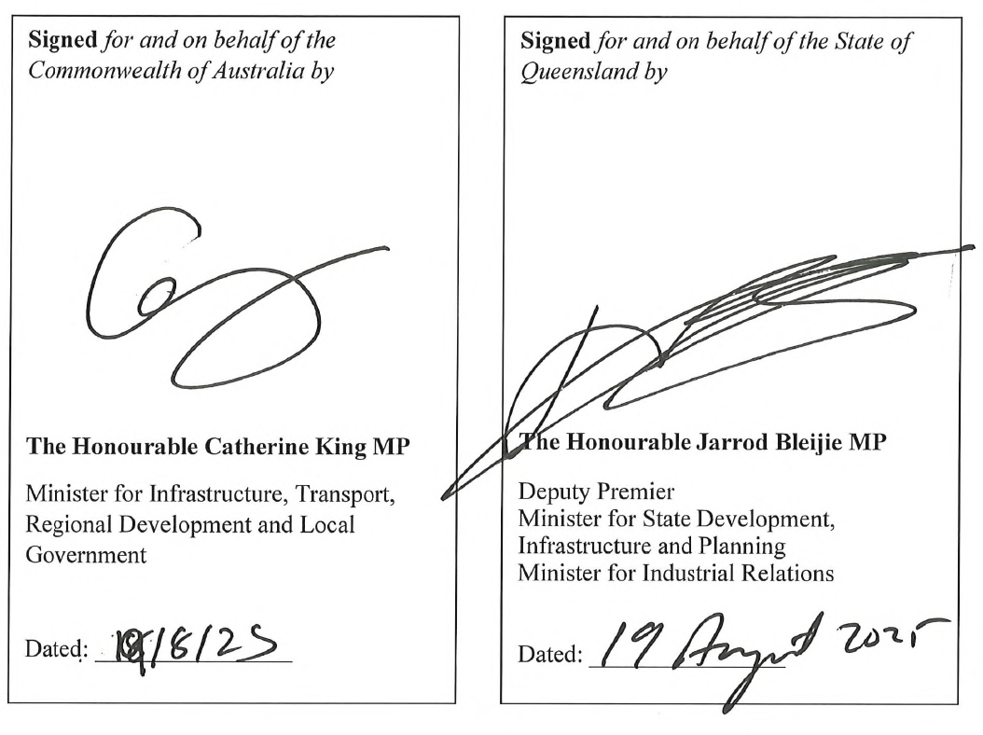

# Annexure A

| **Venue Name** | **New or upgrade** | **Location** |
| --- | --- | --- |
| Stadium* | New | Greater Brisbane |
| National Aquatic Centre | New | Greater Brisbane |
| Para-sport facility – Chandler | New | Greater Brisbane |
| Logan Indoor Sports Centre | New | Greater Brisbane |
| Brisbane Aquatic Centre – Chandler | Existing/upgrade | Greater Brisbane |
| Chandler Precinct works | Existing/upgrade | Greater Brisbane |
| Anna Meares Velodrome– Chandler | Existing/upgrade | Greater Brisbane |
| BMX track – Chandler | Existing/upgrade | Greater Brisbane |
| Brisbane International Shooting Centre | Existing/upgrade | Greater Brisbane |
| Queensland Tennis Centre | Existing/upgrade | Greater Brisbane |
| Redland Whitewater Centre | New | Greater Brisbane |
| Moreton Bay Indoor Sports Centre | New | Greater Brisbane |
| Rockhampton Rowing Facility** | Existing/upgrade | Rockhampton |
| Sunshine Coast Mountain Bike Centre | Existing/upgrade | Sunshine Coast |
| Sunshine Coast Stadium | Existing/Upgrade | Sunshine Coast |
| Barlow Park Stadium | Existing/upgrade | Cairns |
| Toowoomba Equestrian Centre | Existing/upgrade | Toowoomba |
| General allowance for minor upgrades to existing competition and training venues*** | N/A | N/A |

* Funding for the Stadium is subject to Queensland’s completion of a mutually satisfactory stakeholder engagement plan on the Stadium within the Victoria Park Precinct, agreement to develop a new Precinct Plan (including a focus on access to and utility of green space) and a Transport Connectivity Plan, with required transport connectivity being fully funded by Queensland.

**Commonwealth investment is subject to relevant approvals from the appropriate accreditation organisation for use at the Brisbane 2032 Games, and the Commonwealth reserves the right to reallocate funding to more appropriate venues.

***Allocation will be outlined in the FFA, subject to Commonwealth approval from the Ministers with responsibility for this Schedule (or other Ministers as delegated) based on joint principles to be developed and validation work.