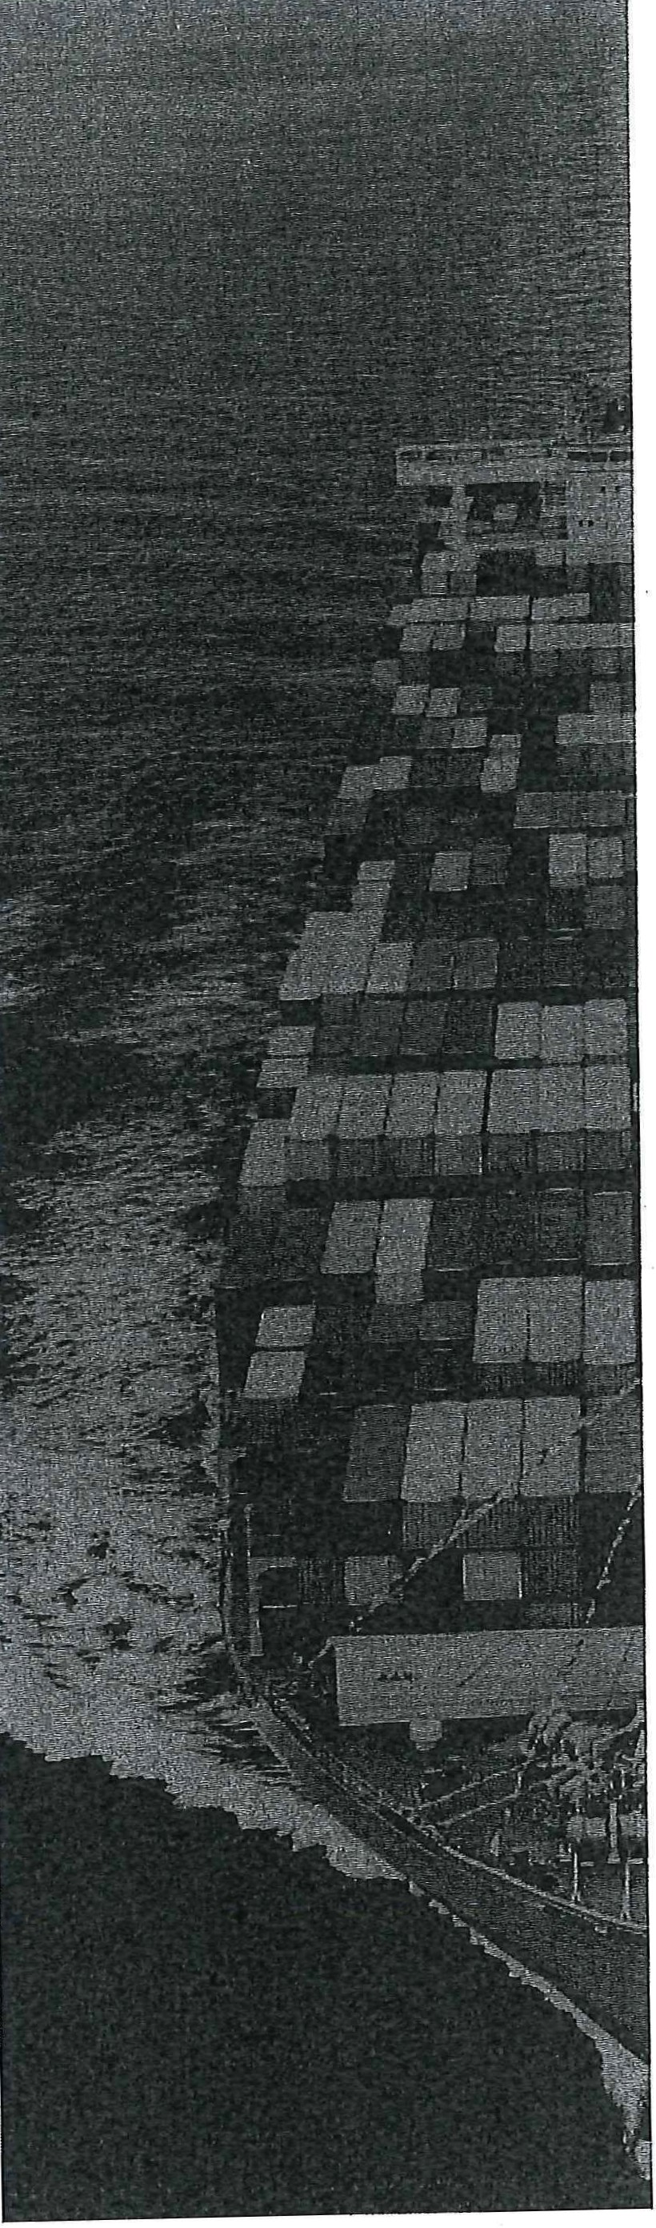
Intergovernmental Agreement on Biosecurity

An agreement between all Australian Governments
- The Commonwealth of Australia
- The State of New South Wales
- The State of Victoria
- The State of Queensland
- The State of Western Australia
- The State of South Australia
- The State of Tasmania
- The Australian Capital Territory
- The Northern Territory of Australia

The objective of this Agreement is to strengthen Australia's biosecurity system through enhanced national collaboration among Australian governments.

This Agreement defines the goal and objectives, and clarifies the roles, responsibilities and governance arrangements, that will guide the Commonwealth and States and Territories in supporting the national biosec ur_it y system.

·· ·-· ·- - - -· -·· · -·-- -•- ····· -- -····--- - . . .. . . ---· · • - · ·· - -· - -···· · •··· - -· · ·· ·· ·· •. .. ---- - 1 1 P a g e

PRELIMINARIES
- This Agreement forms a major element of Australia's biosecurity architecture and establishes for Australian governments (the Parties) their commitments to strengthen, participate in and lead the national biosecurity system by outlining the agreed goal, objectives, roles and responsibilities and governance arrangements.
- Australia, including its external territories, remains free from many pests and diseases that affect agriculture, natural and built environments and people in other parts of the world. This favourable . biosecurity status confers significant economic, environmental and community benefits.
- In signing this Agreement, the Parties acknowledge that sustained and coordinated action is necessary to maintain Australia's favourable national biosecurity status.
- The Parties support a whole-of-government approach to biosecurity, covering. areas including trade, agriculture, forestry, fisheries, tourism, the environment, social amenity and human health.
- This Agreement describes the national biosecurity system primarily for animal, plant and environmental pests and diseases in aquatic (freshwater, estuarine and marine) and terrestrial environments and ecosystems, including pest animals, weeds, fungi and diseases naturally transmitted by and between vertebrate and invertebrate animals and humans. This Agreement does not apply to major animal-borne diseases of humans such as malaria that are primarily managed by Australian and international health agencies.
- The Parties recognise that biosecurity is a responsibility shared by all Australians and that cooperation, investment and action with industry and the community are essential for a strong national biosecurity system. Governments' agreements and arrangements with industry and the community are separate but related to this Agreement.
- Biosecurity management is a complex task and Australia's biosecurity system will need to respond to increasing challenges that are changing its risk profile, including:
  - a changing climate altering the range, habitat and spread of pests and diseases, and increasing severity and frequency of extreme .weather events that assist spread of, and increase the susceptibility of, plants, animals and humans to pests and diseases
  - globalisation increasing the volume and range of products traded inter ationally, passe nger . movements and the subsequent risk of pests and diseases entering and establishing in Australia
  - population spread, shifting demographics and changing land uses increasing the interface between urban and rural areas and the nat ur.al environment, making pest and disease management more complicated and increasing the risk of zoonoses impacting on human health.
- Implementation and ongoing management of this Agreement will occur in conjunction with, and be complementary to, other agreements and arrangements in place to manage biosecurity, which include agreements and arrangements for human biosecurity and national security.

PART 11 THE NATIONAL BIOSECURITY SYSTEM - FOUNDATIONS

Biosecurity .
- Biosecurity is the management of risks .to t he economy, the environment and the community, of pests and diseases entering, emerging, establishing or spreading.
- Australia has obligations under international agreements, including the World Trade Organization, which, among other things, binds members to comply with their obligations under the Agreement on the Application of Sanitary and Phytosanitary Measures (the SPS Agreement) and the Convention on Biological Diversity.
Biosecurity in Australia
- Australia's biosecurity system and favourable biosecurity status confers significant benefits including:
  - enhanced domestic and international trade, with access to markets with specific entry requirements
  - assurance that safe and healthy produce is readily available to domestic and international consumers
  - status as a desirable and rewarding destination for tourists and other visitors
  - protection of our unique, diverse and flourishing native flora and fauna
  - human health and social amenity.
Key biosecurity principles
- Biosecurity is a shared responsibility between al.I system participants.
- In practical terms, zero biosecurity risk is unattainable.
- Biosecurity investment prioritises the allocation of resources to the areas of greatest return, in terms of risk mitigation and return on investment.
- Biosecurity activities are undertaken according to a cost-effective, science-based and ris k-managed appro'ach.
- Governments contribute to the cost of risk management measures in proportion _to the public good accruing from them. other system participants contribute in proportion to the risks created and/or benefits gained.
- System participants are involved in planning and decision making according to their roles, responsibilities and contributions.
- Decisions governments make in further developing and operating our national biosecurity system should be clear and, wherever possible, made pu.bli cly available.
- The Australian community and our trading partners should be informe about the status, quality and performance of our national biosecurity system.
- Australia's biosecurity arrangements comply with its international rights and obligations and with the principle of ecologically sustainable development.
Goal and objectives
- The goal of the national biosecurity system is to minimise adverse impacts of pests and diseases on Australia's economy, environment and the community while facilitating trade and the movement of plants, animals, people and products .
- The objectives of the national biosecurity system are to provide arrangements, structures and frameworks involving governments, industry and community t hat :

3jPage

  - reduce the likelihood of exotic pests and diseases which have the potential to cause significant harm to the economy, the environment, and the community (people, animals and plants) from entering, becoming established or spreading in Australia
  - prepare and ·a ll ow for effective responses to, and management of, exotic and emerging pests and diseases that enter, establish or spread in Australia
  - ensure that, where appropriate, nationally significant pests and diseases already in Australia are contained, suppressed or managed by relevant stakeholders
  - enable international and domestic market access and tourism.
Components of the system
- The national biosecurity system encompasses the full range of activities undertaken by all participants, of which key components include:
  - one Appropriate Level of Protection (ALOP)
  - national lists of exotic priority pests and diseases (for animals, plants and the environment and community)
  - risk analysis system
  - offshore, border and interstate inspection and assessment processes
  - national surveillance and diagnostic systems
  - national emergency preparedness, response and recovery arrangements
  - national reporting and assurance arrangements
  - national performance standards
  - regulatory and operational systems
  - a national information and intelligence system
  - communication and engagement arrangements
    - nationally coordinated priority research
m. national traceability systems.

41Page

PART 2 · I FORMALITIES
Parties to the Agreement
- This Agreement is between the Commonwealth of Australia (the Commonwealth) and the States and Territories, hereafter the Parties.

W hole-of-government arrangements
- In recognition of a whole-of-government approach to biosecurity, each Party will identify a minister responsible for biosecurity matters (Responsible Minister), the lead agency responsible for biosecurity matters (Lead Agency), supporting minister/s and any supporting agency/ies. Parties must notify each other of any changes.
- Within each Party's jurisdiction, each Party will ensure there are appropriate arrangements between a Lead Agency and any supporting agencies, defining the relationship, roles and responsibilities of each agency, including the necessary information flows, deliverables and resources.

Governance
- Implementation and administration of this Agreement will be through the Commonwealth, state and territory Responsible Ministers in consultation with other relevant ministers, including first ministers.
- This Agreement:
  - recognises that biosecurity is a shared responsibility and sets out the principles that will underpin the operation of a national biosecurity system
  - describes the key components of the national biosecurity system, primarily for animal, plant and environmental pests and diseases in both aquatic and terrestrial environments-including zoonotic diseases . Human biosecurity arrangements not covered under .this Agreement are covered by existing arrangements between governments
  - clarifies the respective roles and responsibilities of the Parties in the national biosecurity system
  - describes steps to strengthen the working partnership between the Parties and to enable biosecurity measures to be implemented consistently and efficiently across the biosecurity continuum
  - establishes nationally agreed approaches for the Parties to work together to prevent, prepare for, detect and mitigate biosecurity risks, and respond to, manage and recoverfrom biosecurity incidents should they occur
  - identifies national priorities that the Parties will work on collaboratively to strengthen the national biosecurity system.
- This Agreement constitutes and authorises the National Biosecurity Committee (the Committee) to provide the strategic management and oversight of the national biosecurity system and intergovernmental relationships, and the operation of this Agreement. Each Party will be represented by a Lead Agency senior official, who must present a whole-of-government perspective for that Party.
- The Committee will report to the Agriculture Senior Officials Committee (AGSOC}, which in turn will report to the Agriculture Ministers' Forum (AGMIN), the meeting of Responsible Ministers.

5/Page

PART 3 I COMMITMENTS OF THE PARTIES
- This Agreement recognises that the Parties have some roles and responsibilities that rest solely within a single jurisdiction, where agreement from the other jurisdictions is not required, some will be implemented following intergovernmental consultation, and others will be delivered in partnership.
- The Parties recognise the foundation of institutional relationships and arrangements between governments and the agricultural sector is already well developed. This Agreement will build on these and strengthen arrangements with other indust ries, the erivironmental sector, and the broader community.

Core commitments of the Parties
- Each Party commits to:
  - adhering to and consistently applying the key biosecurity principles (above)
  - maintaining Australia's biosecurity status, recognising its benefits and protections
  - a nationally consistent approach to system activities, measures and components
  - fulfilling, financially resourcing to maintain an effective biosf:curity system a·nd being accountable for their commitments under this Agreement and emergency response deeds and agreements
  - sharing responsibility for biosecurity with .others as appropriate, including facilitating partnerships between governments, industries and the community
  - sharing biosecurity information, data, intelligence and other knowledge necessary for the efficient functioning of the national biosecurity system with other Parties and, where appropriate, with industry and the community
  - managing national priority pests and diseases (aquatic and terrestrial) under a Party's responsibility
  - ongoing stakeholder engagement and communication, and partnership building
  - further developing and continuously improving the national biosecurity system within their jurisdiction and in partnership with other Pa rties; recognising that the rate of progress will be contingent on ava ila ble resources .

Responsibilities of the Commonwealth
- In addition to the responsibilities of all Parties (above), the Commonwealth will take responsibility for:
  - matters relating to the national border, including development and enforcement of quarantine and responding to and controlling detections of exotic pests or diseases that have passed through border controls and are directly related to an imported good or a container carrying an imported good
  - providing national leadership for strategic biosecurity issues, including responses to exotic pests and diseases and management of nationally significant established pests and diseases
  - providing legislati ve, capacity and capability support to States and Territories, as required, to ensure the effective management of biosecurity risks
  - assessing p9tential risks associated with imported goods and conveyances, including leading the development of, in consultat ion with the States and Territories, biosecurity import risk analyses and considering regional differences in pests and disease status and other risk factors
  - managing international government-to-government relatio·ns, including negotiating and facilitating international trade and market access and certifying associated sanitary and phytosanitary cond ition s
  - monitoring and reporting Australia's pest and disease status to meet international obligations and requests from international trading partners and other international bodies
  - incorporating biosecurity risks into threat abatement plans and recovery plans for threatened species and ecological communities

6JPage

  - consulting with the States and Territories on the articulation of Australia's ALOP, priorities for market access requests and biosecurity import risk analyses, including through the Primary Industries Technical Market Access and Trade Development Task Group (or successor bodies)
- fulfilling Australia''s obligations under international agreements and strategies
- biosecurity activities and arrangements in relation to land for which they are responsible.

Responsibilities of the States and Territories
- In addition to the responsibilities of all Parties (above) the States and Territories will take responsibility for
  - biosecurity within their borders, including
- enforcement actions and regulatory interventions
- managing eradication and containment programs for nationally agreed and other pest and disease incursions
- · undertaking surveillance and diagnostics to support early detection and diagnosis
- biosecurity activities on public lands under their jurisdiction and, under certain circumstances, on private lands
- regulating the keeping and movement of plants and animals that pose significant risks
- monitoring pes_t and disease status, including to assist the Commonwealth meet domestic and international obligation s.
  - supporting the Commonwealth in international trade and market access negotiations and requests for information from trading partners
  - negotiating and facilitating domestic trade that is consistent with international obligations and in accordance with clauses 36 to 38
  - maintaining capacity to prepare for, detect and respond to exotic pest and disease incursions
  - supporting landholders and the community to manage established pests and diseases
  - maintaining and administering systems to support agreed national traceability requirements.

Interstate trade responsibilities
- The Parties agree to apply interstate biosecurity measures only to the level necessary to mitigate risks to the economy, environment and the community . Such measures will be the least trade restrictive possible, based on science, applied only to the extent n€cessary to achieve Australia's ALOP and harmonised where possible. The States and Territories will accept alternative interstate biosecurity measures where they achieve equivalent biosecurity risk reductions.
- Subject to scientific evidence, the Parties support the development and maintenance of regional pest and disease status. The Parties will consult and notify each other on the implementation of any changed measure.
- Where an interstate trade dispute arises between the Parties, the relevant Parties will seek to resolve the dispute through a process agreed by the Parties, and include determination on whether appropriate principles and processes were applied in imposing a biosecurity measure.

Biosecurity emergency declaration powers
- The States and Territories support the use of the Commonwealth's power to make a biosecurity emergency declaration in circumstances where these powers are necessary to prevent or control the establishment or spread of a pe,st or disease.
  - Parties acknowledge that, in accordance with the Biosecurity Act 2015 (Cth), these powers may only be used where a pest or disease is posing a severe and immediate threat, or causing harm, on a

7jPage

nationally significant scale, to animal or plant health, the environment, or economic activities related to animals, plants or the environment.

Partnerships
- The Parties will maintain and strengthen cooperative biosecurity partnerships with biosecurity system participants including relevant industries, local governments, environmental groups and the broader community.
- The Parties will seek and facilitate greater involvement of industries and the community in the national biosecurity system, including through Animal Health Australia, Plant Health Australia, Wildlife Health Australia, local governments and/or other relevant groups, . '.

Accountability and reporting
- The Committee will report annually to Responsible Ministers on its work program, implementation of the Agreement, performance indicators and benc.hmarks [once developed and agreed by Responsible Ministers] and identify option·s for remedying areas where unsatisfactory progress is identified. The report will be made public following Responsible Ministers' consideration.
- The AGSOC will establish and oversee an independent Evaluation Program to assess and report on implementation of each Party's commitments under this Agreement, with all Parties assessed within a five (5) year period. The AGSOC will provide Evaluation Reports to Responsible Ministers and make public a summary of each Evaluation Report following Responsible Ministers' consideration.

8JPage

PART 4 I OPERATIVE PROVISIONS

Term of the Agreement
- This Agreement will commence operation between relevant Parties on the date it is signed by the Commonwealth and one or more states or territories and will operate between those Parties that are signatories to this Agreement until there are no remaining state or territory Parties or the Commonwealth is no longer a Party to this Agreement.
- The previous Intergovernmental Agreement on Biosecurity, which came into effect in 2012, will terminate and be replaced by this Agreement at such time as it commences operation in accordance with clause 44.

Variation of the Agreement
- Formal requests to amend this Agreement must be raised at the National Biosecurity Committee, and following a consensus decision, be referred tothe AGSOC, and following a consensus decision be referred to the AGMIN for co nsiderat ion . The AGSOC may determine that an amendment is a minor amendment and does not require referral to the AGMIN.
  - The AGMIN may determine, by consensus, that First Ministers are to be consulted on certain amendments referred to the AGMIN for consideration.
- Unless minor, amendments will operate from the date they are approved by members of the AGMIN that are parties to the Agreement. Minor amendments will operate from the date approved by AGSOC, unless otherwise specified by AGSOC.

Dispute resolution
- Officials of relevant Parties plus an independent chief ex·e cutive officer of a Lead Agency (if possible) will, in the first instance, attempt to resolve any question of interpretation or dispute relevant to this Agreement, with formal notice of the dispute given to Responsible Ministers.
- If the dispute is not resolved within six (6) months of the initial notification of the dispute the Responsible Ministers may appoint an independent mediator to assist the Parties to reach agreement, with any mediation costs incurred to be shared by the disputing parties (unless otherwise agreed), or choose to resolve the dispute under any other mutually agreed process.
SO. Responsible Ministers must be immediately notified of the outcome of the dispute resolution.

- Parties must meet commitments under this Agreement while a dispute remains unresolved.

- Responsible Ministers may refer a dispute to respective First Ministers, if a dispute cannot be resolved by them.

Review of the Agreement
- The Parties must, within five (5) years from commencement, and every 5 years afterwards (or earlier if considered necessary by the Parties), initiate an independent review of the implementation and effectiveness of this Agreement, with input sought from a range of participants in the national biosecurity system, including governments, industries and community members.
- A report must be prepared and presented to the Responsible Ministers and include findings on the implementation and effectiveness of this Agreement and recommendations for amendment. The report will be made public following provision to first ministers, Responsible Ministers and supporting ministe rs.

Withdrawal from the Agreement
- If a Party wishes to withdraw, notice must be given to each Party, which must include the Party's reasons for the withdrawal and the date on which withdrawal becomes effective, being no less than six (6) months from the date of notice.

9 I P a g e

- . Where a Party withdraws, Responsible Minis ters will convene to discuss the implications for this Agreement of the withdrawal of that Party and notify first ministers of the outcome of this d iscussion.
Enforceability of the Agreement
- This Agreement is not intended to create legal relations between the Parties. Notwithstanding this, the Parties in_te nd to comply with all provisions in this Agreement.

10 I Page

Appendix A

GLOSSARY

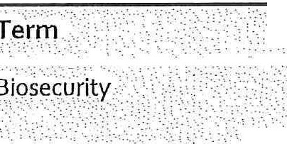
·.·• ·••·•iMe 'r- irig'·•·;.
,.......} ;ti}tt;;\ ffe1t;t 11;; t;t\'!1ttwtr-i ii tt i. tiMMq;etmtYtitY }\'•?
t¢ffi1;tf :J'6,%hiffr .;e;·t

ii ;t rlitm. :¥:rg in{f tir:·•j 1 p:f• iif ti'8:r i i1 riff ,'lrw;:(

•.•Austra lta's economy 'environm ent or:commurnty:•·.•i ·
:.:.·:\t=:f :;,::..:.:\:•:•) \;:.:\ : .::r;::; -\ ) './ .,--( ;; ::\•;:? '.·:::=-:i;:_t:J;:,: :;;-;:;-; -:-:;/;-;:t::·,,:r .:t:=-?:,;_<=::·,.

)m.ffi 1.ii.ibrf
.··.·•.,, ... -­
·.i •r-i •·qf·e h ?r.•.

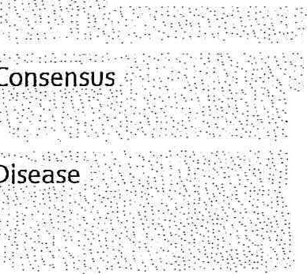
111!iillil llitilfitli\\ill!lll!t!tr@,_{,t}1t_{f:} _{t°:t}
rl '' " '"B' iRgh s; c, 1n; 1:ti1;ii\\i ifbliff}!it\!ill ltt!1ii1t/t;,ttt ;?t t:::id

Em rg_ency Pr pa_redriess,, -The ability t o es'roni:lto' ar( }n rg p y al!ciyy_iri g f rth-e
r () rt qj ervisis nee1- ,91i g?re,ssJbe outbrea'k,
·'> ,, , · , , · · ,
f_f.ic:,·i ,_n, mobil·.i.s..a;t..i.o.:.n:,:n.:d de,pl'o,ym. ept of_ ,

'Envir'orime' ntal :bi s:ec''urity:' :, aTnhdedpirsoetaesctsioennotf rtihneg,e:emvireorngmi_ 'gl'!,ntstna.db/!i<_d:>ihiSnO'gf=piqrl as1p1r1e\!anidtyinfgriofm) Al Uhst'rr,iilslias.a'n,d-,nega:_'tive ffec,t's ·o:f-p',es't'
,<, ,: -
··· M/iiiI«lct, tI1&, ifilf11i;;f i Ji;ti ltiiii;,i;1Il: i;=;:: .,r;;!!i

,-tour·i n;, hu a'n in frast(U re:culturi assei:s a-nd n tio llrn g . ·.. -'_. ' ', . ,,', '

' :,\.·.. ' - ' \ ·.. : ,, ,.;'\ -.- .• ' ·-:- >., .''.1 . ' : . :- :. . '
-' .- .::- :;-·· '

Estab lished Pests a ci ',; a: ' 'f'l, pes·t or aiS \!i'IS that is perpetu i:ep, for.th e fores eable fut re, within any area and here it is not ·. i
, , , . \'/,:.:,;> feas-ib_le (w jl th / lfl t rm; ftei tinical fi i il,ity or- c<?st - ' e!)t na lysi ft9' radi !_\1t e the pes or .
:". ilii ·e.·,..·.a·•...s.e• :.·./\C: ' .. ' ,-,, ;.••;•,.\.·' •·.:"'. \t\·::::.:::, ;., .
:.::·:,=;:;::.;, :.;::i{._-

i:I!tt 1fiJ
]i{{9·t:;).•.'.,._{n•} _{·i}

if ifltbi iM} if,ar
ii '* 't .Ji. ih'.'yfo
fi /i sFfo •i hWfl cigi ti riilJ,.i p c: s

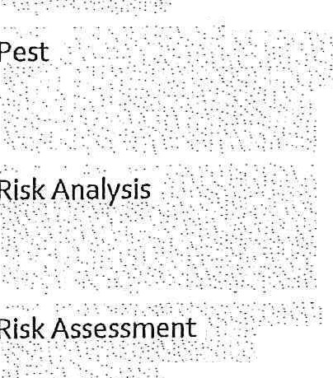
.-' *[!.!1l;f l=;1 !!, t; ;r:l;!{UJ;; r,i;t;: :.<
I!I tlti11,1:11 iuJ:tinifl I ;tit ?til!\ i itit i: fit;i DJJt j.t·

T,h aluation of the li kelihood and the biological, e nvironmenta i,'socia l a d economic

• •·•··•. ;.·. · ··. <' ' : ' ','\:Onsqe
c;e

pf ntry, ek ablish erit, or' spread of a'. pest or di , s.e within the t rritory _of a count ry,

• ••• •,": ·•'\ • > > I '•• .,,.\'.':: • .- '; • t •-•' "\ • : ' • < 0 ', I • \ •. '.
- 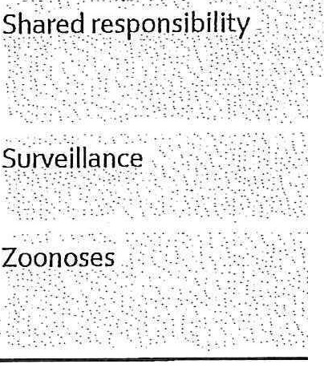:sh;x:tj,:ri s}/q jli.li!Y'.mi. ht Y ; gJ J k,ifi.:r tP8!1 ib.ifaYf9}•. j9{ A r1\yfu i r1 i .h.etb r YF . <i'i

:their_dire¢t. CJntr<'?I br.11ot., EVE!J:YOne 1,as, qblig tionJo tak a t_i9rj to _pe9:t q: ALi t alia fron:1 p sts
d\sei r< ·· ' :.,, · · ..· · · , '
:\ 'a 9
!;::i;},i [1i tai§ irtl; J ;-;t 1:ers: r.P. "1. ?i,es·f. P. it: :r• 1.., ·SE! .' _gi .n:.plant9r. .i .rri _{·i} . ..•·.·.

:r !i!i i;}l\!l{fF1iit0;:trli111rt ;:;i i'.t';:,;;

; •:
?t"t•

11 I P a g e

The Pa rties .have confirmed their commitment to this Agreement as follo ws:

Signed fa and on behalf of the Commonwealth of
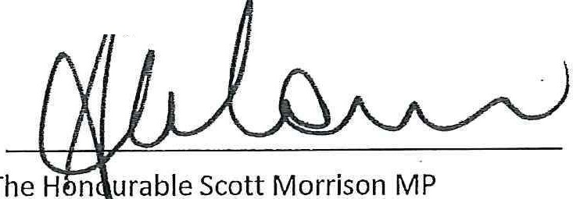
Australia y
Prime Minister of the Commonwealth of Australia [Day] [Month] [Year]

Signed for and on behalf of the State of New South Wales by
Signed for and on behalf of the State of Victoria by

The Honourable Gladys Berejiklian MP Premier· of the State of New South Wales
[Day] [Month] [Year]
The Honourable Daniel Andrews MP Premier of the State of Victoria
[Day] [Month] [Year]

Signed for and on behalf of the State of Queensland by

Signed for and on behalf of the State of Western

[ J,. L

The Honourable Annastacia Palaszczuk MP Premier of the State of Queensland
[Day] [Month] [Year]

Signed for and on behalf of the State of South Australia by
The Honourable Mark McGowan MP Premier of the State of Western Australia
[Day] [Month] [Year]

Signed for and on behalf of the State of Tasmania by

The Honourable Steven Marshall MP Premier of the State of South Australia
[Day] [Month] [Year]

Signed for and on behalf of the Australian Capital Territory by
The Honourable Will Hodgman MP Premier of the State of Tasmania
[Day] [Month] [Year]

Signed for and on behalf of the Northern Territory of Australia by

Andrew Barr MLA
Chief Minister of the Au stralian Capital Territory [Day] [Month] [Year]
The Honourable Michael Gunner MLA
Chief Minister for the Northern Territory of Australia [Day] [Month] [Year}

12 I Page

