A culture of cooperation:
First Secretaries Group’s
Review of Ministerial Councils
Final report to National Cabinet

30 September 2022

Executive summary
One of the first decisions of National Cabinet following the election of the Prime Minister of Australia, the Hon Anthony Albanese MP, was to ask First Secretaries Group (FSG) to review the role of Ministerial Councils. This signalled the combined commitments of First Ministers to ensuring Commonwealth-State relations are operating in a collaborative and consultative manner, and that the appropriate arrangements are in place to support effective decision making for the benefit of all Australians.
As part of this review, National Cabinet asked FSG to provide advice on the role of Ministerial Councils in progressing national priorities with a sharpened focus on productivity. Commonwealth, state and territory governments have all agreed that productivity growth is of central importance to securing Australia’s economic future, supporting real wage growth for Australian workers, and enabling the efficient delivery of government services.
FSG’s Review of Ministerial Councils (the Review) aimed to build on the successes of the National Cabinet model, which has enabled jurisdictions to rapidly respond to the COVID-19 pandemic, as well as drawing on learnings from the previous model of the Council of Australian Governments (COAG). The extensive consultation process and findings of the 2020 Review of the Former COAG Councils and Ministerial Forums (the Conran Review) also informed this Review and its recommendations, particularly in relation to maintaining a streamlined structure, scope and operations.
This Review has developed a refreshed structure for Commonwealth-State ministerial engagement to remove areas of duplication and ensure Ministers can focus on issues of the highest priority. Ministerial Councils specifically tasked by National Cabinet on key priorities, across areas such as skills, childcare, health, productivity and climate change, will report to National Cabinet on the progress of these tasks.
As part of this priority focus, FSG has also put forward specific productivity proposals for National Cabinet’s consideration in the areas of infrastructure and transport; data and digital; human services; and women, to kick start a pipeline of productivity reform across jurisdictions. This will be informed by ongoing work on productivity taking place across governments and Ministerial Councils (including by the Council on Federal Financial Relations and informed by the work of the Productivity Commission) and will be refreshed regularly to ensure momentum is maintained and priorities remain relevant. Other national priorities, including in the areas of housing and the referendum on the Voice to Parliament are also recommended as emerging areas of focus for First Ministers.
More broadly, all Ministerial Councils listed within the federation architecture diagram (Figure 1) will also provide high level annual reporting to National Cabinet on progress across their priorities and work plans.
Other areas were assessed as not requiring a direct reporting line to National Cabinet and as such are not specifically represented in the federation architecture. It is important to note that in these instances, Ministers and Ministerial Councils can continue to progress any portfolio priorities or statutory obligations on an as-needed basis without being formally represented within the architecture or having a reporting line to National Cabinet. This streamlined approach will support National Cabinet to maintain a targeted and united focus on national priorities.
The refreshed structure is accompanied by updated operational and governance principles, which support Ministers to work together to identify and progress their priorities.
Overall, this Review has aimed to ensure that National Cabinet, Ministerial Councils and Commonwealth-State relations more broadly can operate under an enduring structure that promotes collaborative and results-driven decision making, while also being responsive to changing priorities. The proposed changes will support Ministers across jurisdictions to make timely, targeted and transparent decisions for the benefit of all Australians.

Recommendations

Recommendation 1
National Cabinet agree to the proposed model for Australia’s Federal Relations Architecture (Figure 1), which aims to support a more focused strategic agenda and effective coordination on national priorities. This includes:
- Simplifying the architecture by replacing categories of ongoing and time-limited ministers’ meetings, National Cabinet Reform Committees, and the National Federation Reform Council and its taskforces with Ministerial Councils
- Ministerial Councils reporting to National Cabinet annually on work plans and regularly on key priorities as tasked by National Cabinet are:

- Council on Federal Financial Relations
- Data and Digital
- Disability Reform
- Education
- Energy and Climate Change
- Skills and Workforce
- Health
- Housing and Homelessness
- Infrastructure and Transport
- Women and Women’s Safety
- Ministerial Councils reporting annually to National Cabinet are:

- Agriculture
- Attorneys-General
- Community Services
- Emergency Management
- Environment
- Joint Council on Closing the Gap
- Trade and Investment
- Veterans’ Affairs
- Water and Murray Darling Basin

- Continuation of the roles of the Council on Federal Financial Relations (including in relation to Commonwealth-State funding agreements and regulatory reforms) and the Joint Council on Closing the Gap (in supporting the National Agreement on Closing the Gap)
- Ministerial Councils which are not reflected on the diagram and do not report directly to National Cabinet can continue to meet as needed, including to fulfil any statutory obligations, in line with the recommended governance and operational principles
- A Local Government representative could advise National Cabinet on opportunities and challenges within local government that align to national priorities (for example, productivity-enhancing reforms)
- A continued ability for National Cabinet and Ministerial Councils to draw on expert advice as needed but that experts are not needed to be represented in the architecture, and
- The Australia-New Zealand Counter-Terrorism Committee (ANZCTC) to report to FSG with updates on a regular basis.

Recommendation 2
National Cabinet may task FSG to drive progress on a small number of high priority cross-cutting projects requiring First Ministers’ attention. To undertake this work, FSG will:
- Develop further guidance on FSG’s role in the architecture, informed by lessons learnt from this Review and the Improving Care Pathways project
- Collaborate closely with relevant agencies to ensure policy expertise across portfolios is harnessed and proposed recommendations can be implemented
- Engage with experts external to government as required
- Focus on policy integration and joint implementation across jurisdictions and portfolios, and
- Provide clear and regular progress updates to National Cabinet as requested.

Recommendation 3
National Cabinet agree to the following refreshed operating principles for Ministerial Councils that promote a cooperative and collaborative relationship where all jurisdictions are equal partners in decision making. These will be used to update the current Guidance for intergovernmental meetings available on the Federation website:
- Timely administrative processes: The importance of timely distribution of papers, with papers to be circulated at least five business days prior to a meeting. Earlier circulation should be undertaken for major decision items to allow respective jurisdictional Cabinet processes to occur.
- Focused priorities: Agree a work plan of up to five priorities for each year, and for those Councils that report to National Cabinet, work plans will be endorsed by National Cabinet and reported on annually.
- Shared agenda setting: Opportunity for all jurisdictions to put forward agenda items in consultation with the chair/s or by agreement of a majority of members.
- Clear decision making processes: A preference for consensus based decision making while also reflecting the needs and legislative requirements of individual Ministerial Councils.
- Informed and collaborative decision making: Including flexibility for additional Ministers from a jurisdiction, senior officials or expert advisers to attend Ministerial Council meetings to support Ministers, particularly for cross-portfolio issues.
- Adequate resourcing: Have an option for a permanent secretariat (by decision of Ministerial Council) with the opportunity for this to be reviewed on an annual or two-yearly basis, noting the varying capacities of jurisdictions.
- Flexible chairing arrangements: Flexibility to introduce a rotating or shared chair arrangement by agreement of the Ministerial Council, with the opportunity for this to be reviewed on an annual or two-yearly basis, noting the varying capacities of jurisdictions.
- Regular meeting attendance: Hold at least two meetings each year.

Recommendation 4
National Cabinet agree to a reporting framework for all Ministerial Councils represented on the federation architecture diagram at Figure 1 that consists of:
- An annual report to National Cabinet on Ministerial Council priorities/annual work plans, achievements over the past 12 months, and any refreshed terms of reference
- FSG recommendations on any refinements to the architecture required based on annual reports and changes to priorities, and
- FSG developing further guidance on the reporting framework to be provided to Ministerial Councils.

Recommendation 5
National Cabinet continue to drive progress across current national priorities and consider actions on emerging priorities, including in the following areas:
Agreed current priorities
- Supporting parents’ workforce participation through long-term reform of the Early Childhood Education and Care sector (tasked to Education Ministers)
- Actions to accelerate the delivery of nationally significant transmission projects (tasked to Energy and Climate Change Ministers)
- Skills reform including the interim Skills Agreement and a new National Skills Agreement (tasked to Skills Ministers)
- A common set of principles for an orderly transition to a clean energy future (tasked to FSG)
- Regulatory and productivity reform (tasked to Treasurers).
Emerging priorities
- Actions arising from the FSG Improving Care Pathways Project (tasked to Health and Disability Ministers)
- Actions on progressing the referendum on the First Nations Voice to Parliament (tasked to Indigenous Affairs Ministers)
- Housing actions as tasked by National Cabinet (tasked to Housing Ministers).

Recommendation 6
National Cabinet consider tasking relevant Ministerial Councils with the following additional priority tasks, with a focus on improving productivity:
- Actions to address market capacity constraints affecting the construction industry (tasked to Infrastructure and Transport Ministers)
- Improving interoperability of rail systems and streamline approvals processes for national transport infrastructure projects (tasked to Infrastructure and Transport Ministers)
- Delivering government services that are fit for the digital age, including through implementing a federated ecosystem of digital identities and identifying opportunities to deliver seamless government services across jurisdictions (tasked to Data and Digital Ministers)
- Increasing gender balance across the labour market, through setting targets for gender balance across highly gender-segregated industries and having governments take a procurement-led approach to gender equality (tasked to Ministers for Women and Women’s Safety)
- Improving productivity and outcomes in the human services sector (including health and education), through bringing together governments, service providers, the not for profit sector and participants to identify and implement improvements to service provision (tasked to FSG as a cross-portfolio priority with relevant Ministers).

Recommendation 7
National Cabinet monitor and progress its strategic agenda by:
- Tasking CFFR to provide advice annually to National Cabinet on possible additional productivity priorities, including areas where National Cabinet involvement can help progress priorities or unlock barriers, with the first of these reviews to occur following the release of the Productivity Commission’s five yearly productivity inquiry report in 2023, and
- Tasking relevant Ministerial Councils to regularly report on progress against the priority tasks, which would include:
  - A summary of milestones met
  - Next steps and expected finalisation timelines, and
  - Issues for National Cabinet’s involvement and/or resolution.

Figure 1
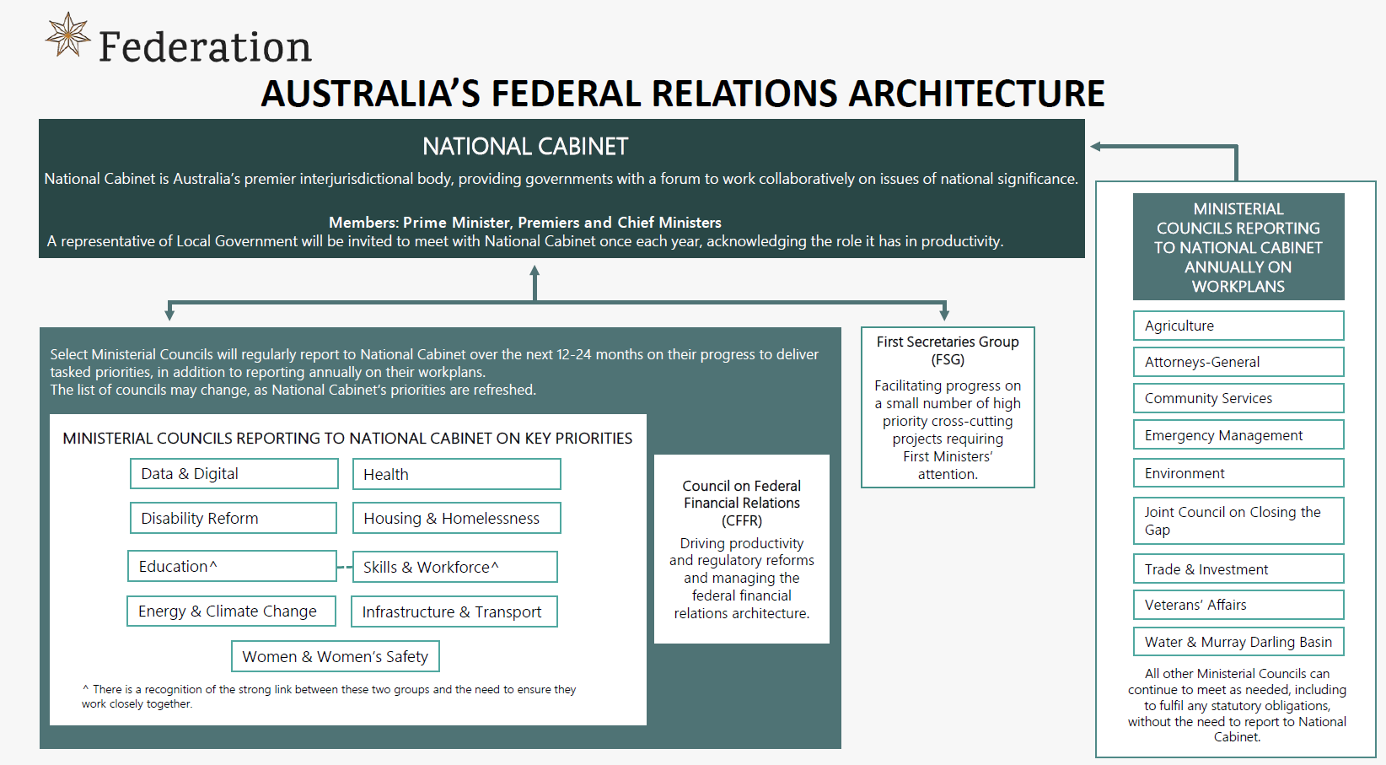
Figure description in the appendix

Figure 2
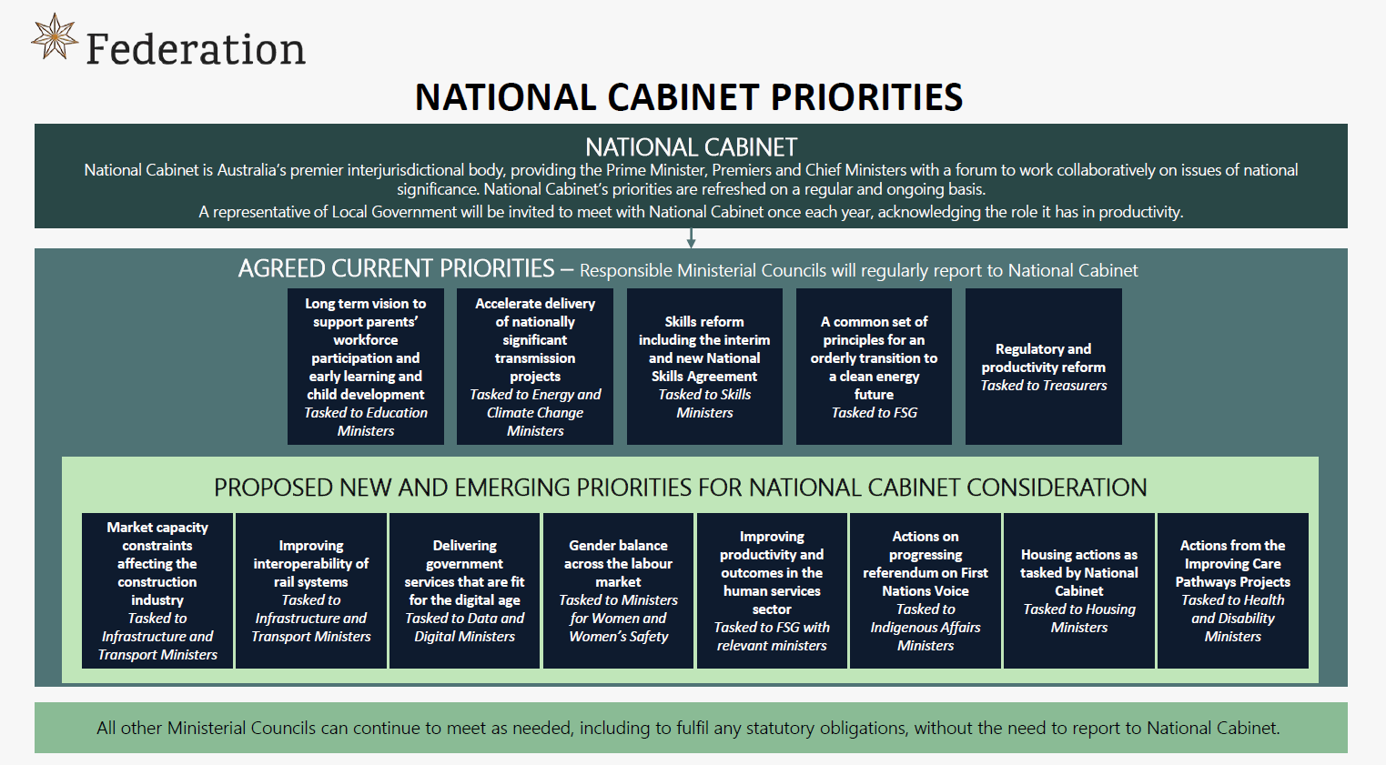
Figure description in the appendix

Appendix

Figure 1 – Text description
This figure outlines the Australian federal relations architecture.
National Cabinet is Australia’s premier interjurisdictional body, providing governments with a forum to work collaboratively on issues of national significance. The Prime Minister, Premiers and Chief Ministers are members. A representative of Local Government will be invited to meet with National Cabinet once each year, acknowledging the role it has in productivity.
Select Ministerial Councils will regularly report to National Cabinet over the next 12-24 months on their progress to deliver tasked priorities, in addition to reporting annually on their workplans. The list of councils may change, as National Cabinet’s priorities are refreshed. The list of Ministerial Councils reporting to National Cabinet on key priorities is:
- Data and Digital
- Health
- Disability Reform
- Housing and Homelessness
- Education
- Skills and Workforce
- Energy and Climate Change
- Infrastructure and Transport
- Women and Women’s Safety.
There is a recognition of the strong link between Education and Skills & Workforce and the need to ensure they work closely together.
The Council on Federal Financial Relations supports National Cabinet by driving productivity and regulatory reforms, and managing the federal financial relations architecture.
The First Secretaries Group facilitates progress on a small number of high priority cross-cutting projects requiring First Ministers’ attention.
Separately, there are a number of other Ministerial Councils that are not tasked with delivering specific priorities, but are required to report annually to National Cabinet on their workplans. These are:
- Agriculture
- Attorneys-General
- Community Services
- Emergency Management
- Environment
- Joint Council on Closing the Gap
- Trade and Investment
- Veterans’ Affairs
- Water and Murray-Darling Basin
All other Ministerial Councils can continue to meet as needed, including to fulfil any statutory obligations, without the need to report to National Cabinet.
Return to text following Figure 1

Figure 2 – Text description
This figure outlines the key priorities for National Cabinet.
National Cabinet is Australia’s premier interjurisdictional body, providing the Prime Minister, Premiers and Chief Ministers with a forum to work collaboratively on issues of national significance. National Cabinet’s priorities are refreshed on a regular and ongoing basis. A representative of local government will be invited to meet with National Cabinet once each year, acknowledging the role it has in productivity.
The agreed current priorities are:
- Long term vision to support parents’ workforce participation and early learning and child development – Tasked to Education Ministers
- Accelerate delivery of nationally significant transmission projects – Tasked to Energy and Climate Change Ministers
- Skills reform including the interim and new National Skills Agreement – Tasked to Skills Ministers
- A common set of principles for an orderly transition to a clean energy future – Tasked to First Secretaries
- Regulatory and productivity reform – Tasked to Treasurers
The proposed new and emerging priorities for National Cabinet consideration are:
- Market capacity constraints affecting the construction industry – Tasked to Infrastructure and Transport Ministers
- Improving interoperability of rail systems – Tasked to Infrastructure and Transport Ministers
- Delivering government services that are fit for the digital age – Tasked to Data and Digital Ministers
- Gender balance across the labour market – Tasked to Ministers for Women and Women’s Safety
- Improving productivity and outcomes in the human services sector – Tasked to FSG with relevant ministers
- Actions on progressing referendum on First Nations Voice – Tasked to Indigenous Affairs Ministers
- Housing actions as tasked by National Cabinet – Tasked to Housing Ministers
- Actions from the Improving Care Pathways Projects – Tasked to Health and Disability Ministers
All other Ministerial Councils can continue to meet as needed, including to fulfil any statutory obligations, without the need to report to National Cabinet.
Return to text following Figure 2

